·:Lpath CONTROLLED FORM IICGIPOIITII TITLE: GXP and Non-GXP Study Repot1 Review and Approval F01m I DOCUMENT NO. VERSION ISSUE DATE EFFECTIVE DATE PAGE I I GE003FM01 02 17 Oct 2014 20 Oct 2014 I 2 of2 o vendor Study Protocol O vendor Study Report [{] Lpath Study Report Lpath Study No.: LT 3114-PHA-014-R Version No.: ~~Non GXP r- GLP GCP GMP Product Name: LT 3114 Test Article: B3;LT 3015;L T3017;LT 3114 Study Title: Comparison of the binding of anti-LPA antibodies to other lipid molecules (cross-reactivity) I U N! I Study Vendor/Site: N/A Study Director: A Study Contributor(s): O N/A LPath Rosalia Matteo Kelli Moreno Vendor Study No.Nersion: (Z]N/A Study Dates: Report Date: Jan 2010 Jan 2010 ON/A Lab Notebook Reference: LNBs#181 pp.66-95;ELISA Binder#5,Tab 181 []N;A Executive summary of study results: O see Attached The ability of several anti-lysophosphatidic acid (anti-LPA) antibodies (both murine, 63, and humanized: LT 3015; LT 3017; LT 3114) to bind to a range of lipids that are structurally and chemically similar to LP was examined in a competition ELISA format. Lipids at varying concentrations were added to the test antibodies in a 3:1 ratio (Lipid:Ab) and then added to plates (100 IJI/well in triplicate) coated with 18:0 LPA and the ability of the antibodies to bind to the plate in the presence of potentially competing ligands was assessed. There was no significant cross-reactivity of any of the antibodies with the lipids tested up to a concentration of 5 iJM lipid with the exception of LPA itself. LI’ATII AI’I’ROVAL Function Name (Print) Signature Date Study Director/Monitor ~lta_ ~t:tlfL-o ~~~., ;) H ll2. t 2-oM il_~ Contributor ~u”’f /7 p-+1- I t/ }lf I 2£’ LY <;;c.. Research c~.–r C> ooJ n.v1f ~₋)~ t) l’Z. /t.ot_
Development JM,~ ~~·~ -l.( ~ It/I j /l#lf- –~ -..;;;) Quality Assurance I?J., v ! .f!, rf 41/JIZil.t/“€ 2 &&!/~ _{j?}pc?/7 I ..j ·:L ath P.. ……. CONFIDENTIAL
Table (source: module4_extracted/Comparison of the binding of anti-LPA antibodies to other lipid molecules (cross-reactivity)/tables/table_page_1_idx_1.csv)
·:Lpath IICGIPOIITII
CONTROLLED FORM
TITLE: GXP and Non-GXP Study Repot1 Review and Approval F01m
None
INO. VERSION ISSUE DATE EFFECTIVE DATE PAGEI003FM01 02 17 Oct 2014 20 Oct 2014 I 2 of2
None
Table (source: module4_extracted/Comparison of the binding of anti-LPA antibodies to other lipid molecules (cross-reactivity)/tables/table_page_1_idx_2.csv)
o vendor Study Protocol O vendor Study Report [{] Lpath Study Report
None
None
None
None
None
None
None
None
None
Lpath Study No.: LT 3114-PHA-014-R
None
Version No.: ~
None
None
~Non
None
None
r-
GLP
Product Name: LT 3114
None
Test Article: B3;LT 3015;L T3017;LT 3114
None
None
None
None
None
None
None
Study Title: Comparison of the binding of anti-LPA antibodies to other lipid molecules (cross-reactivity)
None
None
None
None
None
None
None
None
None
I U N! IVendor/Site: N/A Study Director: A Study Contributor(s): O N/ARosalia Matteo Kelli Moreno
None
None
None
None
None
None
None
None
None
Vendor Study No.Nersion: (Z]N/A
None
None
Study Dates:
None
None
Report Date:
None
None
None
ON/ANotebook Reference: LNBs#181 pp.66-95;ELISA Binder#5,Tab 181
None
None
None
None
None
None
None
None
None
[]N;Asummary of study results: O see Attachedability of several anti-lysophosphatidic acid (anti-LPA) antibodies (both murine, 63, and humanized: LT 3015;; LT 3114) to bind to a range of lipids that are structurally and chemically similar to LP was examined in aELISA format. Lipids at varying concentrations were added to the test antibodies in a 3:1 ratio (Lipid:Ab) andadded to plates (100 IJI/well in triplicate) coated with 18:0 LPA and the ability of the antibodies to bind to the plate inpresence of potentially competing ligands was assessed.was no significant cross-reactivity of any of the antibodies with the lipids tested up to a concentration of 5 iJM lipidthe exception of LPA itself.
None
None
None
None
None
None
None
None
None
LI’ATII AI’I’ROVAL
None
None
None
None
None
None
None
None
None
Function
Name (Print)
None
None
Signature
None
None
Date
None
None
Study Director/Monitor
~lta_ ~t:tlfL-o
None
None
~~~., ;)_~
None
None
H ll2. t-oM
None
None
Contributor
~u”’f
None
None
p-+1-/7
None
None
I t/ }lf I 2£’ LY <;;c..
None
None
Research
ooJ n.v1f~.–r C>
None
None
~₋)~
None
None
t) l’Z. /t.ot/td>
None
<td>None</td>
</tr>
<tr>
<th></th>
<td>Development JM,~ ~~~~·~</td>
<td>None</td>
<td>None</td>
<td>None</td>
<td>c_ \\n-l.( ~</td>
<td>None</td>
<td>None</td>
<td>It/I j /l#lf-</td>
<td>None</td>
<td>None</td>
</tr>
<tr>
<th></th>
<td>None</td>
<td>None</td>
<td>None</td>
<td>None</td>
<td>--~\n-..;;;)</td>
<td>None</td>
<td>None</td>
<td>None</td>
<td>None</td>
<td>None</td>
</tr>
<tr>
<th></th>
<td>Quality Assurance</td>
<td>I?J., v ! .f!, rf 41/JIZil.t/"€ 2</td>
<td>None</td>
<td>None</td>
<td>&amp;~~&amp;!/~</td>
<td>None</td>
<td>None</td>
<td>None</td>
<td>None</td>
<td>None</td>
</tr>
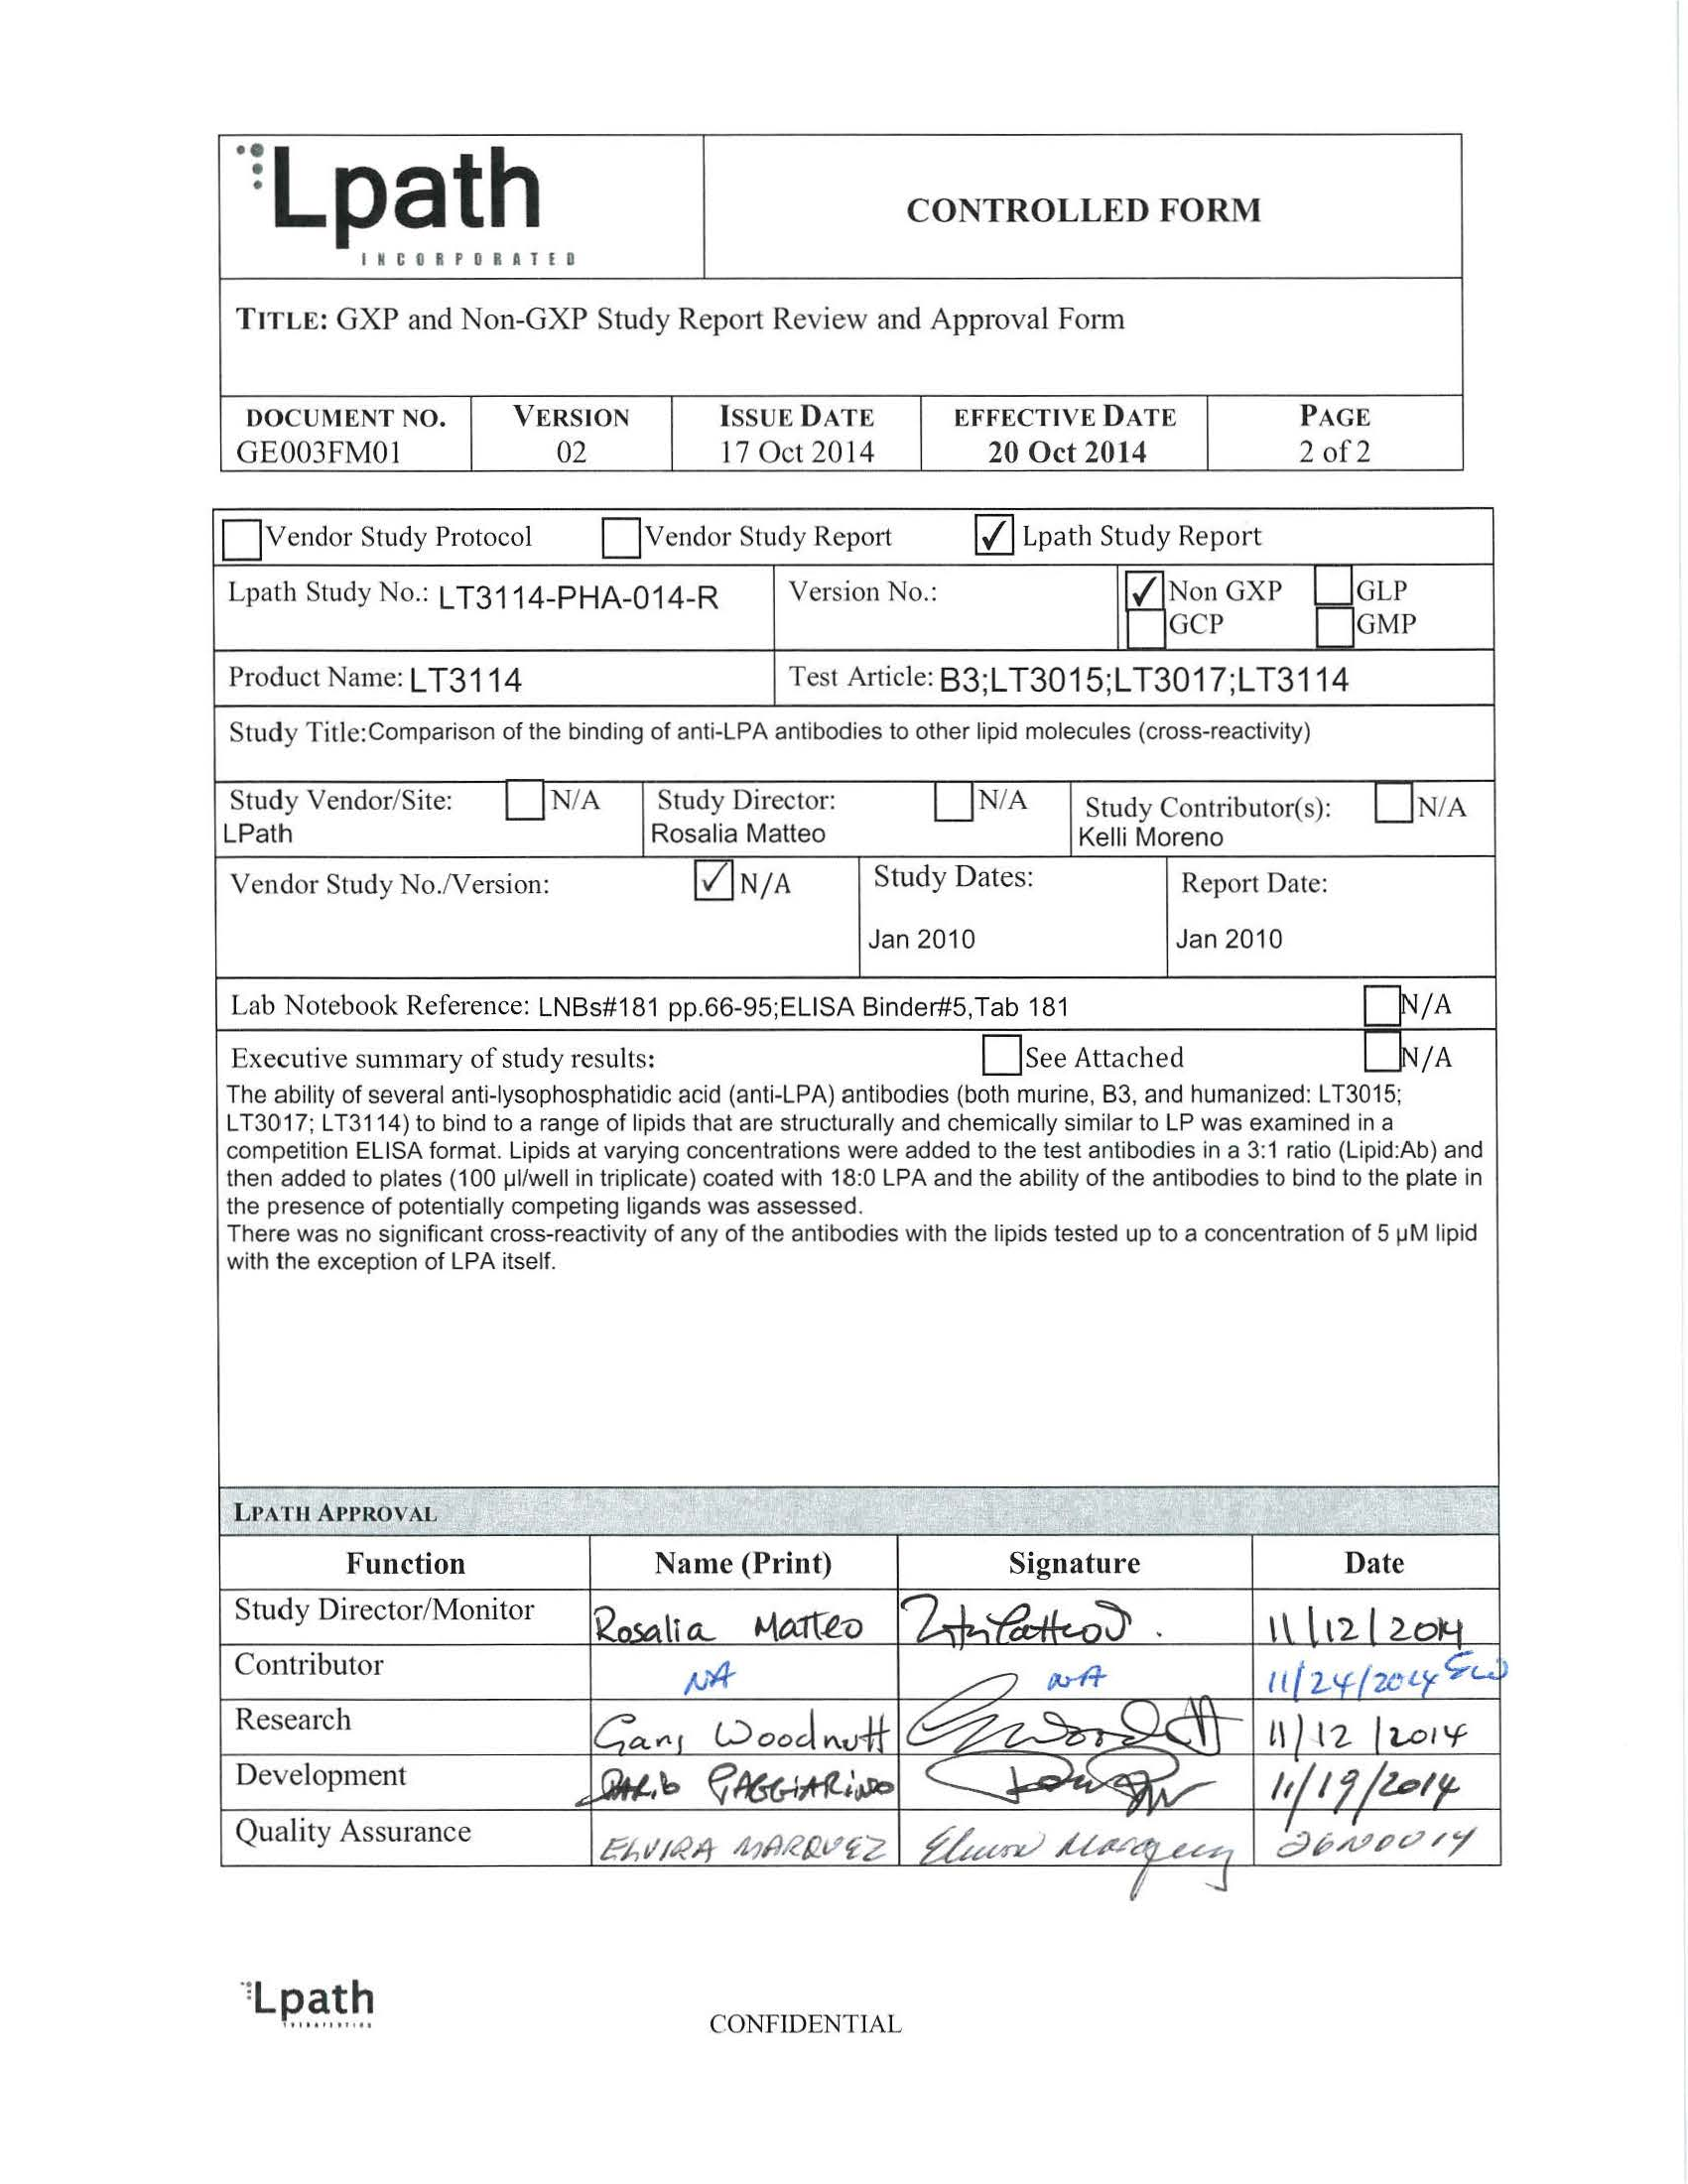
Image page 1 #1
Report Number: LT3114-PHA-014-R Title: Comparison of the binding of anti-LPA antibodies to other Page 1 of 20 lipid molecules (cross-reactivity) Comparison of the binding of anti-LPA antibodies to other lipid molecules (cross-reactivity) Document Type Final Report Study Monitor Rosalia Matteo Study Director Kelli Moreno Performance Site (s) LPath Project Study Number SN-LPA_9081 Initiation Date January 2010 Completion Date January 2010 Date FSR January 2010 GLP, GMP or GCP Non- GLP Number of Pages 20 Description Test Article Humanized and murine Anti-LPA antibodies Archive Lpath CONFIDENTIAL
Table (source: module4_extracted/Comparison of the binding of anti-LPA antibodies to other lipid molecules (cross-reactivity)/tables/table_page_2_idx_1.csv)
0
1
Report Number: LT3114-PHA-014-R: Comparison of the binding of anti-LPA antibodies to othermolecules (cross-reactivity)
Page 1 of 20
Report Number: LT3114-PHA-014-R Title: Comparison of the binding of anti-LPA antibodies to other Page 2 of 20 lipid molecules (cross-reactivity) TABLE OF CONTENTS 1 SUMMARY ………………………………………………………………………………………………………..3 2 INTRODUCTION ……………………………………………………………………………………………….3 3 MATERIALS AND METHODS ……………………………………………………………………………3 3.1 Test Articles ……………………………………………………………………………………………….3 3.2 ELISA methodology ……………………………………………………………………………………5 4 RESULTS …………………………………………………………………………………………………………..6 5 CONCLUSIONS………………………………………………………………………………………………….7 6 DATA ARCHIVE ………………………………………………………………………………………………..8 7 APPENDICES …………………………………………………………………………………………………….9 LIST OF IN-TEXT TABLES Table 1 Lipids that show similarity to LPA that were used to test for cross- reactivity …………………………………………………………………………………………4 Table 2 Humanized and murine antibodies used in these experiments ………………..5 Table 3 Percent Inhibition of antibody binding to 18:0 LPA at 2.5 µM lipid ……….7 CONFIDENTIAL
Table (source: module4_extracted/Comparison of the binding of anti-LPA antibodies to other lipid molecules (cross-reactivity)/tables/table_page_3_idx_1.csv)
0
1
Report Number: LT3114-PHA-014-R: Comparison of the binding of anti-LPA antibodies to othermolecules (cross-reactivity)
Page 2 of 20
Report Number: LT3114-PHA-014-R Title: Comparison of the binding of anti-LPA antibodies to other Page 3 of 20 lipid molecules (cross-reactivity) 1 SUMMARY The ability of several anti-lysophosphatidic acid (anti-LPA) antibodies (both murine, B3, and humanized: LT3015; LT3017; LT3114) to bind to a range of lipids that are structurally and chemically similar to LPA was examined in a competition ELISA format. Lipids at varying concentrations were added to the test antibodies in a 3:1 ratio (Lipid:Ab) and then added to plates (100 µl/well in triplicate) coated with 18:0 LPA and the ability of the antibodies to bind to the plate in the presence of potentially competing ligands was assessed. There was no significant cross-reactivity of any of the antibodies with the lipids tested up to a concentration of 5 µM lipid with the exception of LPA itself. 2 INTRODUCTION The bioactive lipid lysophosphatidic acid (LPA) is an important extracellular signaling molecule in neuropathic pain. LPA and its receptors are responsible for long-lasting mechanical allodynia and thermal hyperalgesia as well as demyelination and upregulation of pain-related protein expression patterns in a variety of animal models. Evidence supports the hypothesis that antagonism of the LPA signaling pathways would benefit the treatment of neuropathic pain. We have developed the first high affinity monoclonal antibodies targeting LPA (anti-LPA mAb) and the studies described here were performed to examine the potential for these antibodies to bind other lipids which are structurally similar to LPA. 3 MATERIALS AND METHODS 3.1 Test Articles The range of lipids tested in this study is shown in Table 1. Antibodies that were used to examine competitive binding are detailed in Table 2. CONFIDENTIAL
Table (source: module4_extracted/Comparison of the binding of anti-LPA antibodies to other lipid molecules (cross-reactivity)/tables/table_page_4_idx_1.csv)
0
1
Report Number: LT3114-PHA-014-R: Comparison of the binding of anti-LPA antibodies to othermolecules (cross-reactivity)
Page 3 of 20
Report Number: LT3114-PHA-014-R Title: Comparison of the binding of anti-LPA antibodies to other Page 4 of 20 lipid molecules (cross-reactivity) Table 1 Lipids that show similarity to LPA that were used to test for cross- reactivity Lipid “common” name Chemical name Vendor Cat. no. Inventory Id. 72 Lysophosphatidic Acid (18:2) 1-Linoleoyl LPA Echelon L-0182 Lysophosphatidic Acid (C18:1) 1-(9Z-octadecenyl)-2-hydroxy-sn- 76 alkyl glycero-3-phosphate Avanti 857230 1 Sphingosine-1-Phosphate D-erythro-Sphingosine-1-Phosphate Avanti 860492 3 D-erythro Sphingosine D-erythro-Sphingosine (Synthetic) Avanti 860490 D-erythro-Sphingosine Phosphocholine (Lyso 5 Sphingosine Phosphocholine Sphingomyelin) Avanti 860600 Lysophosphatidylcholine 1-Stearoyl-2-Hydroxy-sn-Glycerol-3- 43 (C18:0) Phosphocholine Avanti 855775 Lysophosphatidylethanolamine 1-Stearoyl-2-Hydroxy-sn-Glycerol-3- 45 (C18:0) Phosphoethanolamine Avanti 856715 Lysophosphatidylglycerol 1-Stearoyl-2-Hydroxy-sn-Glycero-3- 47 (LPG C18:0) [Phosho-rac-1-glycerol)] Avanti 858124 1-Oleoyl-2-hydroxy-sn-glycerol-3- 87 LPS (18:1) phospho-L-serine Avanti 858143 1-Olyoyl-2-Hydroxy-sn-Glycero-3- 90 18:1 Lyso PI Phosphoinositol Avanti 850100 1,2-Dipalmitoyl-sn-Glycero-3- [Phospho-L-Serine] (Sodium Salt) 8 Phosphatidylserine (PS 16:0) (DPPS) Avanti 840037 1-Palmitoyl-2-Oleoyl-sn-Glycero-3- 34 16:0-18:1 PC Phosphocholine (16:0-18:1) Avanti 850457 1,2-Dilinoleoyl-sn-Glycero-3- 35 Phosphatidylglycerol (18:2 PG) [Phospho-rac-(1-glycerol)] Avanti 840485 Phosphatidic Acid 16:0-18:1 1-Palmitoyl-2-Oleoyl-sn-Glycero-3- 36 PA Phosphate (16:0-18:1) Avanti 840857 1,2-dieladoyl-sn-glycero-3- 88 18:1 (∆9-trans) PE phosphoethanolamine Avanti 850726 1,2-diundecanoyl-sn-glycero-3- 89 11:0 PC phosphocholine Avanti 850330 1-Alkyl-2-Acetoyl-sn-Glycero-3- 14 PAF Phosphocholine Avanti 840009 1-Oleoyl-sn-Glycero-2-3-Cyclic- 16 cyclic LPA (18:1) Phosphate Avanti 857328 19 Lyso PAF 1-Alkyl-2-Hydroxy-sn-Glycero-3- Avanti 840008 CONFIDENTIAL
Table (source: module4_extracted/Comparison of the binding of anti-LPA antibodies to other lipid molecules (cross-reactivity)/tables/table_page_5_idx_1.csv)
0
1
Report Number: LT3114-PHA-014-R: Comparison of the binding of anti-LPA antibodies to othermolecules (cross-reactivity)
Page 4 of 20
Table (source: module4_extracted/Comparison of the binding of anti-LPA antibodies to other lipid molecules (cross-reactivity)/tables/table_page_5_idx_2.csv)
Lipid Inventory Id.
“common” name
Chemical name
Vendor
Cat. no.
72
Lysophosphatidic Acid (18:2)
1-Linoleoyl LPA
Echelon
L-0182
76
Lysophosphatidic Acid (C18:1)
1-(9Z-octadecenyl)-2-hydroxy-sn--phosphate
Avanti
857230
1
Sphingosine-1-Phosphate
D-erythro-Sphingosine-1-Phosphate
Avanti
860492
3
D-erythro Sphingosine
D-erythro-Sphingosine (Synthetic)
Avanti
860490
5
Sphingosine Phosphocholine
D-erythro-Sphingosine(Lyso)
Avanti
860600
43
Lysophosphatidylcholine(C18:0)
1-Stearoyl-2-Hydroxy-sn-Glycerol-3-
Avanti
855775
45
Lysophosphatidylethanolamine(C18:0)
1-Stearoyl-2-Hydroxy-sn-Glycerol-3-
Avanti
856715
47
Lysophosphatidylglycerol(LPG C18:0)
1-Stearoyl-2-Hydroxy-sn-Glycero-3-
Avanti
858124
87
LPS (18:1)
1-Oleoyl-2-hydroxy-sn-glycerol-3--L-serine
Avanti
858143
90
18:1 Lyso PI
1-Olyoyl-2-Hydroxy-sn-Glycero-3-
Avanti
850100
8
Phosphatidylserine (PS 16:0)
1,2-Dipalmitoyl-sn-Glycero-3-(Sodium Salt)(DPPS)
Avanti
840037
34
16:0-18:1 PC
1-Palmitoyl-2-Oleoyl-sn-Glycero-3-(16:0-18:1)
Avanti
850457
35
Phosphatidylglycerol (18:2 PG)
1,2-Dilinoleoyl-sn-Glycero-3-
Avanti
840485
36
Phosphatidic Acid 16:0-18:1
1-Palmitoyl-2-Oleoyl-sn-Glycero-3-(16:0-18:1)
Avanti
840857
88
18:1 (∆9-trans) PE
1,2-dieladoyl-sn-glycero-3-
Avanti
850726
89
11:0 PC
1,2-diundecanoyl-sn-glycero-3-
Avanti
850330
14
PAF
1-Alkyl-2-Acetoyl-sn-Glycero-3-
Avanti
840009
16
cyclic LPA (18:1)
1-Oleoyl-sn-Glycero-2-3-Cyclic-
Avanti
857328
19
Lyso PAF
1-Alkyl-2-Hydroxy-sn-Glycero-3-
Avanti
840008
Report Number: LT3114-PHA-014-R Title: Comparison of the binding of anti-LPA antibodies to other Page 5 of 20 lipid molecules (cross-reactivity) Table 1 Lipids that show similarity to LPA that were used to test for cross- reactivity Phosphocholine 1-Bromo-3(S)-hydroxy-4- 86 BrP-LPA (palmitoyloxy) butyl] phosphonate Echelon L-7416 50 Diacylglycerol (18:1 DG) 1,2-dioleoyl-sn-glycerol Avanti 800811 (R,R)-2,2’-Bisdodecyl-LBPA L- 85 C12-ether LBPA ammonium salt Echelon B120e 91 2-AG 2-arachidonoyl glycerol Avanti 870450 Glycerol phosphate (40%) Fluka 3391 Table 2 Humanized and murine antibodies used in these experiments Antibody Part Number Target Lot Number Concentration Dilution (mg/mL) (µg/mL) Humanized LT 3015 LPA LR81055 19.3 mg/ml 0.5 µg/ml anti-LPA Humanized LT 3017 LPA LP91090-42 0.91 mg/ml 0.5 µg/ml anti-LPA Humanized LT 3114 LPA LP91183 1.54 mg/ml 0.5 µg/ml anti-LPA Murine anti- 504B3 LPA LP91172 11.4 mg/ml 0.5 µg/ml LPA 3.2 ELISA methodology The specificity of the humanized antibody was determined by competition ELISA. 18:0 LPA coating material is diluted to 0.33 µg/ml in carbonate buffer (100 mM NaHCO , 33.6 mM 3 Na CO pH 9.5). Plates are coated with 100 µl/well of this coating solution and incubated at 2 3, 37°C for 1 hour. The plates are then washed 4X with PBS (100 mM Na HPO 20 mM 2 4, KH PO 27 mM KCl, 1.37 mM NaCl, pH 7.4) and blocked with 150 µl/well PBS + 1% BSA 2 4, + 0.1% tween-20 for 1 hour at room temperature. The humanized anti-LPA antibody variants and the murine B3 antibody were tested against lipids that are structurally and chemically similar to LPA at 5 µM, 2.5 µM, 1.25 µM, 0.625 µM, and 0.0 µuM. The antibodies are diluted to 0.5 µg/ml in PBS +0.1 % tween-20 and combined with the lipid samples at a 1:3 ratio of antibody to sample on a non-binding plate (recommended 100 µl Ab CONFIDENTIAL
Table (source: module4_extracted/Comparison of the binding of anti-LPA antibodies to other lipid molecules (cross-reactivity)/tables/table_page_6_idx_1.csv)
0
1
Report Number: LT3114-PHA-014-R: Comparison of the binding of anti-LPA antibodies to othermolecules (cross-reactivity)
Page 5 of 20
Table (source: module4_extracted/Comparison of the binding of anti-LPA antibodies to other lipid molecules (cross-reactivity)/tables/table_page_6_idx_2.csv)
Phosphocholine
86
BrP-LPA
1-Bromo-3(S)-hydroxy-4-(palmitoyloxy) butyl] phosphonate
Echelon
L-7416
50
Diacylglycerol (18:1 DG)
1,2-dioleoyl-sn-glycerol
Avanti
800811
85
C12-ether LBPA
(R,R)-2,2’-Bisdodecyl-LBPAsalt
Echelon
L-120e
91
2-AG
2-arachidonoyl glycerol
Avanti
870450
Glycerol phosphate (40%)
Fluka
3391
Table (source: module4_extracted/Comparison of the binding of anti-LPA antibodies to other lipid molecules (cross-reactivity)/tables/table_page_6_idx_3.csv)
Antibody
Part Number
Target
Lot Number
Concentration (mg/mL)
Dilution (µg/mL)
Humanized-LPA
LT 3015
LPA
LR81055
19.3 mg/ml
0.5 µg/ml
Humanized-LPA
LT 3017
LPA
LP91090-42
0.91 mg/ml
0.5 µg/ml
Humanized-LPA
LT 3114
LPA
LP91183
1.54 mg/ml
0.5 µg/ml
Murine anti-
504B3
LPA
LP91172
11.4 mg/ml
0.5 µg/ml
Report Number: LT3114-PHA-014-R Title: Comparison of the binding of anti-LPA antibodies to other Page 6 of 20 lipid molecules (cross-reactivity) and 300 µl samples/standards, enough to run in triplicate). The plates are washed 4X with PBS and then incubated for 1 hour at room temperature with 100 µl/well of the primary antibody combined with the samples. Next the plates are washed 4X with PBS and then incubated for 1 hour at room temperature with 100 µl/well of HRP-conjugated goat anti- human or murine antibody diluted 1:20,000 in PBS + 1% BSA + 0.1% tween-20. Again the plates are washed 4X with PBS and developed using 100 µl/well TMB substrate at 4°C. After 8 minutes, the reaction is stopped with 1M H SO 100 µl/well. The optical 2 4, density (OD) was measured at 450 nm using a Thermo Multiskan EX. Raw data were transferred to GraphPad software for analysis of competition curves. Values for percent inhibition at 2.5 µM lipid were also calculated for each lipid using Microsoft Excel. 4 RESULTS Competition curves for all lipids tested are shown. Individual data tables for these lipids are detailed in Appendix 1. Data showing the percent inhibition of all lipids at 2.5uM is summarized in Table 3. Overall, as expected the only lipid that demonstrated significant competition with the coating material (18:0 LPA) for binding was LPA 18:2. 18:1 alkyl-LPA also showed a low level of inhibition in these assay but none of the remaining lipids showed a significant level of cross-reactivity as measured by competition for plated 18:0 LPA. CONFIDENTIAL
Table (source: module4_extracted/Comparison of the binding of anti-LPA antibodies to other lipid molecules (cross-reactivity)/tables/table_page_7_idx_1.csv)
0
1
Report Number: LT3114-PHA-014-R: Comparison of the binding of anti-LPA antibodies to othermolecules (cross-reactivity)
Page 6 of 20
Report Number: LT3114-PHA-014-R Title: Comparison of the binding of anti-LPA antibodies to other Page 7 of 20 lipid molecules (cross-reactivity) Table 3 Percent Inhibition of antibody binding to 18:0 LPA at 2.5 µM lipid Lipid LT 3015 LT3017 LT3114 B3 LPA 18:2 44% 47% 61% 71% LPA C18:1 12% 12% 20% 30% S1P -1% 0% -10% 4% sphingosine 5% 8% 7% 3% sphingosine phosphocholine 3% 3% -1% 2% Lysophosphatidylcholine (C18:0) 2% 2% 2% -2% Lysophosphatidylethanolamine (C18:0) 5% 1% -3% -2% Lysophosphatidylglycerol (LPG C18:0) 7% 3% 7% 8% LPS C18:1 3% 0% -1% 2% 18:1 Lyso PI -1% -3% 0% 3% phosphatidylserine (PS 16:0) 0% 2% 1% 3% Phosphocholine(16:0-18:1) 0% 3% 0% 1% Phosphatidylglycerol (18:2 PG) 8% 14% 6% 0% Phosphatidic Acid 16:0-18:1 PA 1% 0% 1% 0% 18:1 (∆9-trans) PE 6% 6% 0% 6% 11:0 PC 2% 1% 1% -1% PAF 12% -6% -5% 4% cyclic LPA (18:1) -13% 9% 9% 16% Lyso PAF 2% 7% 0% 6% BrP-LPA 2% -1% -5% 6% Diacylglycerol (18:1 DG) -3% -1% -5% -5% C12-ether LBPA -5% 1% -1% 2% 2-AG 7% 3% 8% 7% glycerol phosphate 5% 3% 1% 3% 5 CONCLUSIONS There is no significant cross-reactivity with any of the lipids tested up to 5 µM with the exception of LPA. CONFIDENTIAL
Table (source: module4_extracted/Comparison of the binding of anti-LPA antibodies to other lipid molecules (cross-reactivity)/tables/table_page_8_idx_1.csv)
0
1
Report Number: LT3114-PHA-014-R: Comparison of the binding of anti-LPA antibodies to othermolecules (cross-reactivity)
Page 7 of 20
Table (source: module4_extracted/Comparison of the binding of anti-LPA antibodies to other lipid molecules (cross-reactivity)/tables/table_page_8_idx_2.csv)
0
1
2
3
4
Lipid
LT 3015
LT3017
LT3114
B3
Report Number: LT3114-PHA-014-R Title: Comparison of the binding of anti-LPA antibodies to other Page 8 of 20 lipid molecules (cross-reactivity) 6 DATA ARCHIVE Lpath Notebooks #181, pp. 66-95 ELISA Binder #5, Tab 181. L:ProjectprojectPlates Abs-hu Abs CONFIDENTIAL
Table (source: module4_extracted/Comparison of the binding of anti-LPA antibodies to other lipid molecules (cross-reactivity)/tables/table_page_9_idx_1.csv)
0
1
Report Number: LT3114-PHA-014-R: Comparison of the binding of anti-LPA antibodies to othermolecules (cross-reactivity)
Page 8 of 20
Report Number: LT3114-PHA-014-R Title: Comparison of the binding of anti-LPA antibodies to other Page 9 of 20 lipid molecules (cross-reactivity) 7 APPENDICES Appendix 1 Competition curves of all lipids tested CONFIDENTIAL
Table (source: module4_extracted/Comparison of the binding of anti-LPA antibodies to other lipid molecules (cross-reactivity)/tables/table_page_10_idx_1.csv)
0
1
Report Number: LT3114-PHA-014-R: Comparison of the binding of anti-LPA antibodies to othermolecules (cross-reactivity)
Page 9 of 20
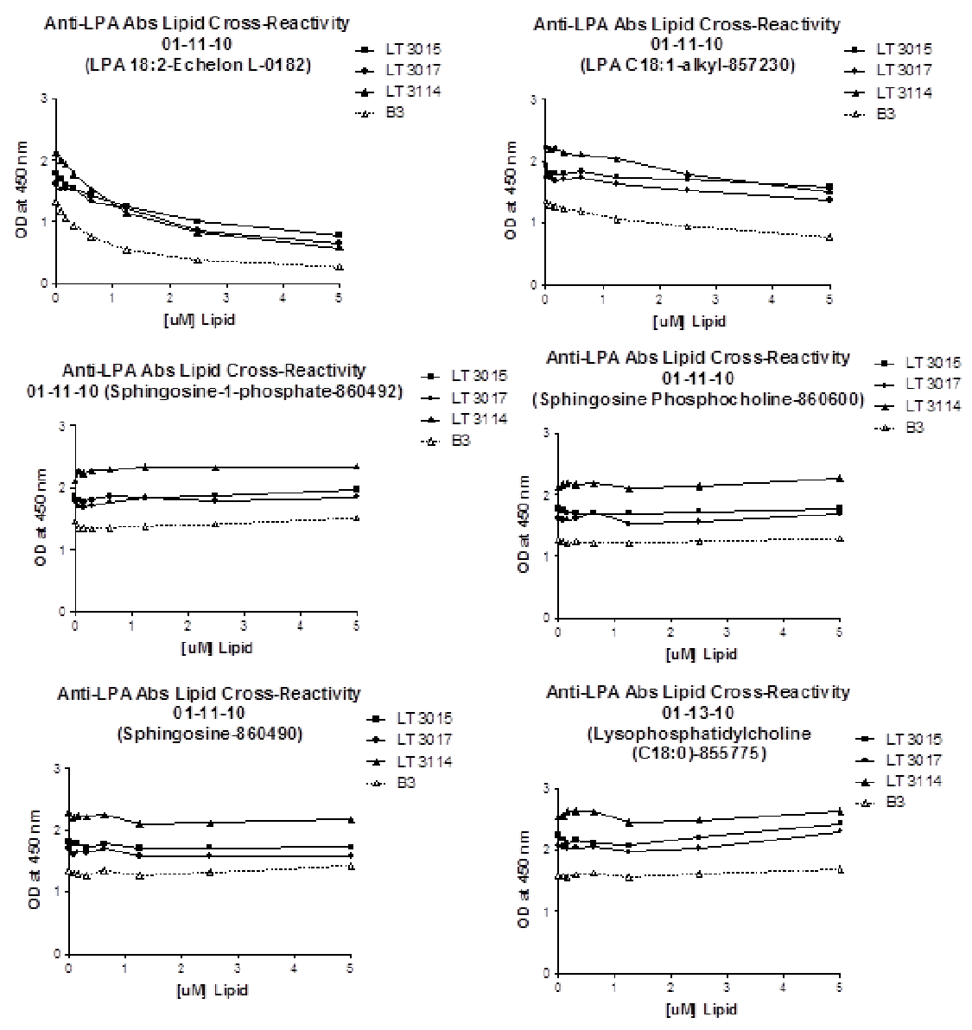
Image page 10 #1
Report Number: LT3114-PHA-014-R Title: Comparison of the binding of anti-LPA antibodies to other Page 10 of 20 lipid molecules (cross-reactivity) CONFIDENTIAL
Table (source: module4_extracted/Comparison of the binding of anti-LPA antibodies to other lipid molecules (cross-reactivity)/tables/table_page_11_idx_1.csv)
0
1
Report Number: LT3114-PHA-014-R: Comparison of the binding of anti-LPA antibodies to othermolecules (cross-reactivity)
Page 10 of 20
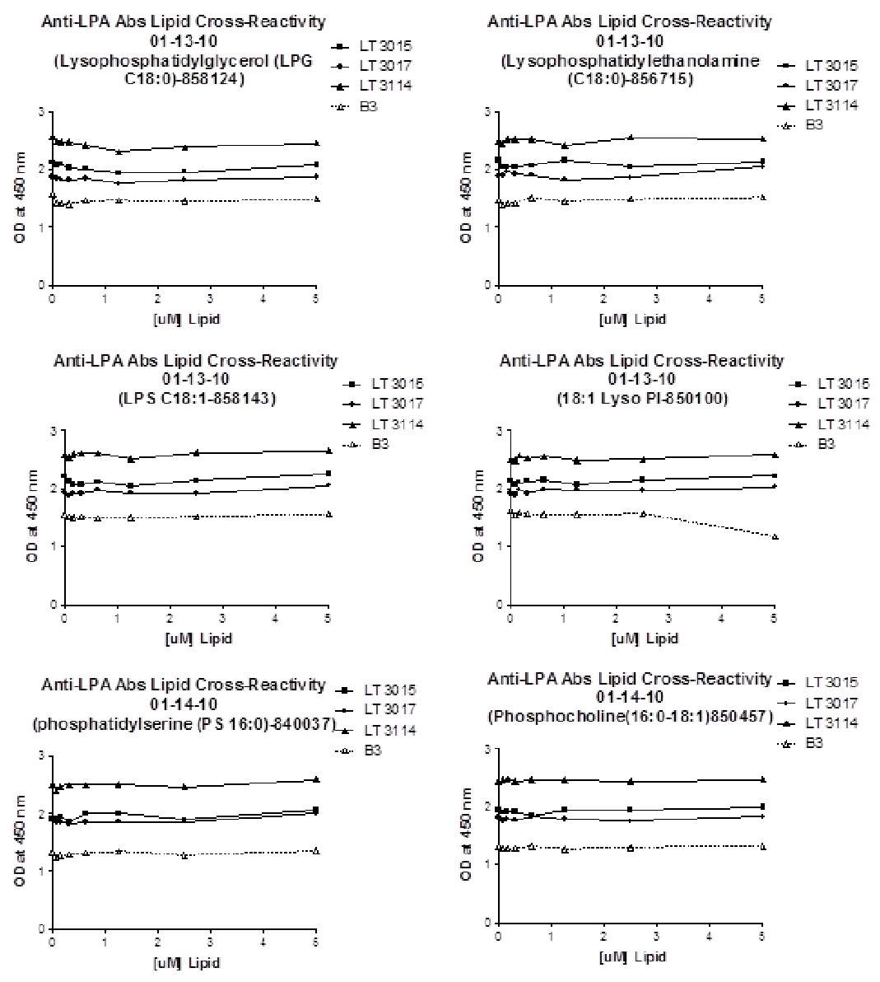
Image page 11 #1
Report Number: LT3114-PHA-014-R Title: Comparison of the binding of anti-LPA antibodies to other Page 11 of 20 lipid molecules (cross-reactivity) CONFIDENTIAL
Table (source: module4_extracted/Comparison of the binding of anti-LPA antibodies to other lipid molecules (cross-reactivity)/tables/table_page_12_idx_1.csv)
0
1
Report Number: LT3114-PHA-014-R: Comparison of the binding of anti-LPA antibodies to othermolecules (cross-reactivity)
Page 11 of 20
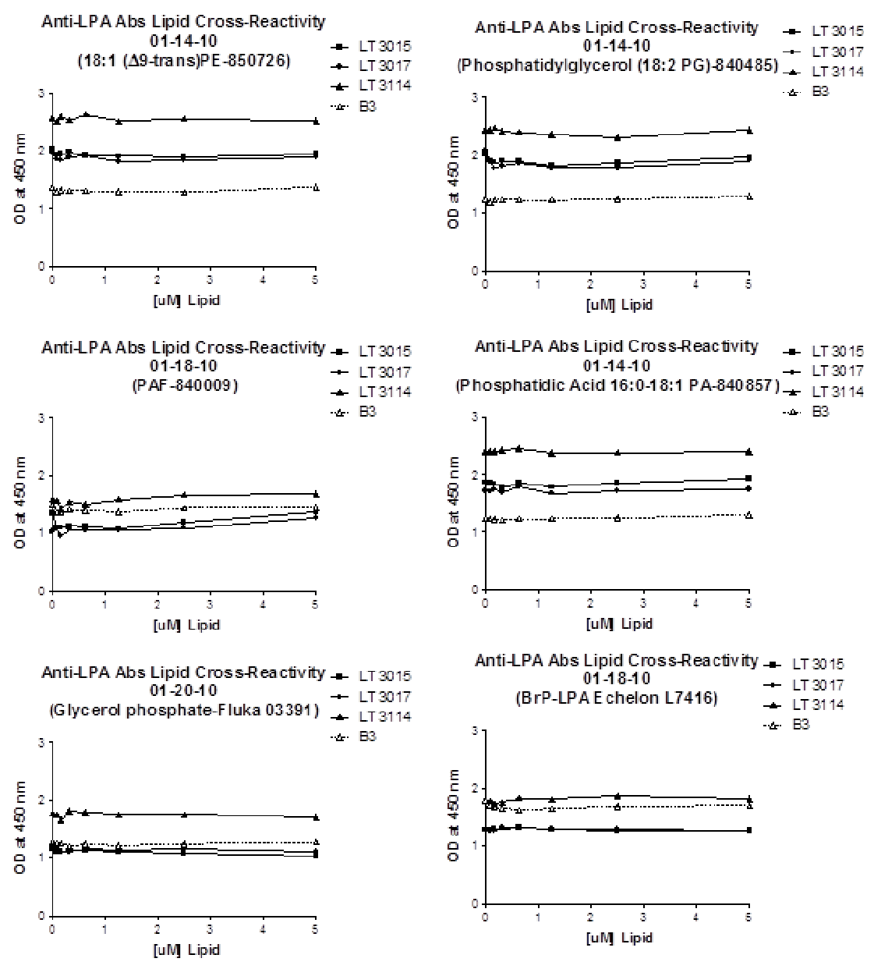
Image page 12 #1
Report Number: LT3114-PHA-014-R Title: Comparison of the binding of anti-LPA antibodies to other Page 12 of 20 lipid molecules (cross-reactivity) CONFIDENTIAL
Table (source: module4_extracted/Comparison of the binding of anti-LPA antibodies to other lipid molecules (cross-reactivity)/tables/table_page_13_idx_1.csv)
0
1
Report Number: LT3114-PHA-014-R: Comparison of the binding of anti-LPA antibodies to othermolecules (cross-reactivity)
Page 12 of 20
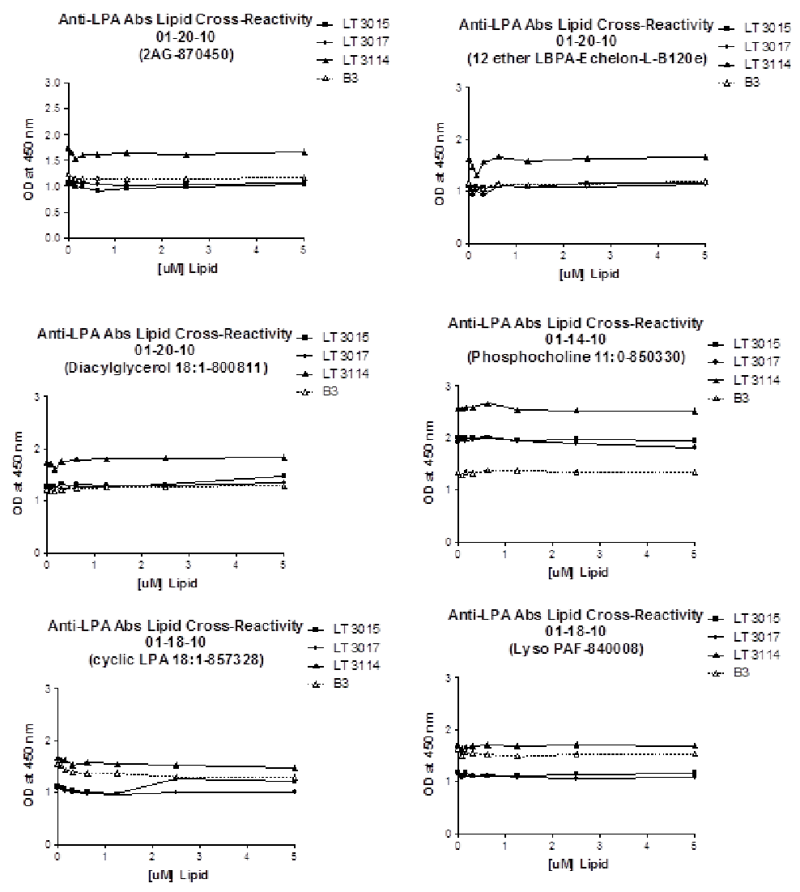
Image page 13 #1
Report Number: LT3114-PHA-014-R Title: Comparison of the binding of anti-LPA antibodies to other Page 13 of 20 lipid molecules (cross-reactivity) Appendix 2 Raw Data Compilation LPA 18:2 LT 3015 LT 3017 LT 3114 B3 5 0.785 0.779 0.755 0.688 0.599 0.657 0.607 0.567 0.573 0.273 0.245 0.275 2.5 1.028 1 0.992 0.879 0.839 0.867 0.85 0.821 0.833 0.383 0.365 0.385 1.25 1.248 1.229 1.257 1.413 1.139 1.108 1.109 1.154 1.151 0.53 0.542 0.541 0.625 1.439 1.423 1.432 1.329 1.321 1.363 1.534 1.501 1.533 0.759 0.752 0.76 0.3125 1.577 1.529 1.516 1.628 1.48 1.487 1.768 1.768 1.767 0.94 0.938 0.934 0.15625 1.616 1.611 1.594 1.571 1.49 1.54 1.916 1.924 1.983 1.071 1.058 1.074 0.078125 1.742 1.669 1.656 1.541 1.516 1.512 1.946 1.985 2.036 1.176 1.172 1.155 0 1.799 1.781 1.785 1.578 1.654 1.618 2.118 2.063 2.191 1.331 1.298 1.344 LPA C18:1 LT 3015 LT 3017 LT 3114 B3 5 1.633 1.557 1.561 1.353 1.408 1.331 1.497 1.57 1.451 0.749 0.766 0.791 2.5 1.719 1.707 1.68 1.568 1.546 1.481 1.766 1.842 1.77 0.943 0.94 0.946 1.25 1.754 1.746 1.731 1.601 1.679 1.606 1.993 1.981 2.119 1.074 1.08 1.026 0.625 1.845 1.828 1.842 1.75 1.751 1.712 2.114 2.099 2.092 1.202 1.171 1.168 0.3125 1.806 1.789 1.795 1.713 1.725 1.702 2.078 2.189 2.138 1.212 1.244 1.224 0.15625 1.816 1.786 1.785 1.67 1.732 1.636 2.214 2.219 2.217 1.262 1.281 1.263 0.078125 1.796 1.796 1.792 1.726 1.715 1.742 2.173 2.173 2.212 1.3 1.29 1.28 0 2.028 1.882 1.883 1.762 1.767 1.691 2.234 2.272 2.237 1.36 1.326 1.366 S1P LT 3015 LT 3017 LT 3114 B3 5 1.996 1.97 1.931 1.806 1.871 1.873 2.473 2.172 2.387 1.452 1.522 1.556 2.5 1.874 1.881 1.872 1.804 1.804 1.759 2.377 2.298 2.303 1.403 1.426 1.395 1.25 1.786 1.841 1.851 1.909 1.882 1.759 2.346 2.298 2.356 1.374 1.385 1.367 0.625 1.836 1.871 1.883 1.796 1.731 1.794 2.245 2.305 2.329 1.358 1.36 1.325 0.3125 1.816 1.833 1.772 1.663 1.756 1.719 2.293 2.293 2.235 1.312 1.35 1.324 0.15625 1.732 1.831 1.771 1.7 1.731 1.636 2.238 2.238 2.228 1.35 1.351 1.342 0.078125 1.775 1.839 1.797 1.686 1.758 1.654 2.267 2.271 2.287 1.316 1.374 1.358 0 1.915 1.868 1.802 1.762 1.797 1.797 2.106 2.138 2.103 1.432 1.479 1.475 CONFIDENTIAL
Table (source: module4_extracted/Comparison of the binding of anti-LPA antibodies to other lipid molecules (cross-reactivity)/tables/table_page_14_idx_1.csv)
0
1
Report Number: LT3114-PHA-014-R: Comparison of the binding of anti-LPA antibodies to othermolecules (cross-reactivity)
Page 13 of 20
Table (source: module4_extracted/Comparison of the binding of anti-LPA antibodies to other lipid molecules (cross-reactivity)/tables/table_page_14_idx_2.csv)
LPA 18:2
LT 3015
None
None
None
None
None
None
LT 3017
None
None
None
None
None
None
LT 3114
None
None
None
None
None
None
B3
None
None
None
None
None
None
5
0.785
0.779
0.755
0.688
0.599
0.657
0.607
0.567
0.573
0.273
0.245
0.275
2.5
1.028
1
0.992
0.879
0.839
0.867
0.85
0.821
0.833
0.383
0.365
0.385
1.25
1.248
1.229
1.257
1.413
1.139
1.108
1.109
1.154
1.151
0.53
0.542
0.541
0.625
1.439
1.423
1.432
1.329
1.321
1.363
1.534
1.501
1.533
0.759
0.752
0.76
0.3125
1.577
1.529
1.516
1.628
1.48
1.487
1.768
1.768
1.767
0.94
0.938
0.934
0.15625
1.616
1.611
1.594
1.571
1.49
1.54
1.916
1.924
1.983
1.071
1.058
1.074
0.078125
1.742
1.669
1.656
1.541
1.516
1.512
1.946
1.985
2.036
1.176
1.172
1.155
0
1.799
1.781
1.785
1.578
1.654
1.618
2.118
2.063
2.191
1.331
1.298
1.344
LPA C18:1
LT 3015
None
None
None
None
None
None
LT 3017
None
None
None
None
None
None
LT 3114
None
None
None
None
None
None
B3
None
None
None
None
None
None
5
1.633
1.557
1.561
1.353
1.408
1.331
1.497
1.57
1.451
0.749
0.766
0.791
2.5
1.719
1.707
1.68
1.568
1.546
1.481
1.766
1.842
1.77
0.943
0.94
0.946
1.25
1.754
1.746
1.731
1.601
1.679
1.606
1.993
1.981
2.119
1.074
1.08
1.026
0.625
1.845
1.828
1.842
1.75
1.751
1.712
2.114
2.099
2.092
1.202
1.171
1.168
0.3125
1.806
1.789
1.795
1.713
1.725
1.702
2.078
2.189
2.138
1.212
1.244
1.224
0.15625
1.816
1.786
1.785
1.67
1.732
1.636
2.214
2.219
2.217
1.262
1.281
1.263
0.078125
1.796
1.796
1.792
1.726
1.715
1.742
2.173
2.173
2.212
1.3
1.29
1.28
0
2.028
1.882
1.883
1.762
1.767
1.691
2.234
2.272
2.237
1.36
1.326
1.366
S1P
LT 3015
None
None
None
None
None
None
LT 3017
None
None
None
None
None
None
LT 3114
None
None
None
None
None
None
B3
None
None
None
None
None
None
5
1.996
1.97
1.931
1.806
1.871
1.873
2.473
2.172
2.387
1.452
1.522
1.556
2.5
1.874
1.881
1.872
1.804
1.804
1.759
2.377
2.298
2.303
1.403
1.426
1.395
1.25
1.786
1.841
1.851
1.909
1.882
1.759
2.346
2.298
2.356
1.374
1.385
1.367
0.625
1.836
1.871
1.883
1.796
1.731
1.794
2.245
2.305
2.329
1.358
1.36
1.325
0.3125
1.816
1.833
1.772
1.663
1.756
1.719
2.293
2.293
2.235
1.312
1.35
1.324
0.15625
1.732
1.831
1.771
1.7
1.731
1.636
2.238
2.238
2.228
1.35
1.351
1.342
0.078125
1.775
1.839
1.797
1.686
1.758
1.654
2.267
2.271
2.287
1.316
1.374
1.358
0
1.915
1.868
1.802
1.762
1.797
1.797
2.106
2.138
2.103
1.432
1.479
1.475
Report Number: LT3114-PHA-014-R Title: Comparison of the binding of anti-LPA antibodies to other Page 14 of 20 lipid molecules (cross-reactivity) Sphingosine LT 3015 LT 3017 LT 3114 B3 5 1.748 1.711 1.701 1.55 1.602 1.602 2.142 2.18 2.173 1.39 1.466 1.407 2.5 1.721 1.721 1.704 1.637 1.508 1.571 2.084 2.109 2.137 1.3 1.326 1.308 1.25 1.671 1.702 1.736 1.616 1.549 1.554 2.053 2.115 2.113 1.228 1.259 1.318 0.625 1.774 1.772 1.769 1.719 1.691 1.676 2.276 2.268 2.191 1.338 1.337 1.339 0.3125 1.735 1.69 1.689 1.608 1.663 1.623 2.235 2.205 2.203 1.246 1.237 1.314 0.15625 1.798 1.784 1.774 1.643 1.653 1.633 2.197 2.232 2.235 1.28 1.286 1.286 0.078125 1.874 1.703 1.767 1.631 1.578 1.615 2.151 2.205 2.232 1.242 1.31 1.372 0 1.873 1.776 1.78 1.733 1.711 1.695 2.278 2.278 2.281 1.275 1.383 1.377 SPC LT 3015 LT 3017 LT 3114 B3 5 1.82 1.785 1.729 1.692 1.726 1.662 2.264 2.273 2.249 1.257 1.248 1.352 2.5 1.773 1.728 1.688 1.552 1.575 1.555 2.146 2.083 2.189 1.184 1.233 1.291 1.25 1.717 1.705 1.684 1.541 1.55 1.48 2.082 2.08 2.132 1.2 1.215 1.225 0.625 1.7 1.688 1.715 1.943 1.622 1.557 2.18 2.156 2.195 1.156 1.234 1.237 0.3125 1.752 1.701 1.659 1.638 1.644 1.571 2.198 2.163 2.139 1.216 1.174 1.313 0.15625 1.768 1.703 1.663 1.599 1.615 1.58 2.213 2.165 2.176 1.186 1.191 1.254 0.078125 1.759 1.76 1.72 1.644 1.617 1.504 2.157 2.157 2.173 1.195 1.25 1.259 0 1.857 1.744 1.736 1.589 1.63 1.623 2.117 2.134 2.123 1.178 1.287 1.329 LPC 18:0 LT 3015 LT 3017 LT 3114 B3 5 2.488 2.392 2.4 2.285 2.344 2.267 2.645 2.604 2.645 1.631 1.665 1.756 2.5 2.347 2.148 2.106 1.987 2.098 1.987 2.477 2.477 2.481 1.568 1.576 1.684 1.25 2.098 2.036 2.075 1.927 1.988 1.967 2.411 2.431 2.476 1.547 1.539 1.58 0.625 2.14 2.07 2.114 1.996 2.057 2.085 2.642 2.575 2.642 1.588 1.594 1.684 0.3125 2.263 2.07 2.137 2.018 2.042 2.046 2.609 2.669 2.598 1.565 1.557 1.663 0.15625 2.119 2.125 2.069 2.002 2.072 2.021 2.633 2.604 2.633 1.538 1.55 1.599 0.078125 2.157 2.095 2.26 1.982 2.125 2.04 2.642 2.493 2.493 1.499 1.529 1.691 0 2.397 2.137 2.169 1.973 2.133 2.111 2.542 2.558 2.522 1.539 1.564 1.63 CONFIDENTIAL
Table (source: module4_extracted/Comparison of the binding of anti-LPA antibodies to other lipid molecules (cross-reactivity)/tables/table_page_15_idx_1.csv)
0
1
Report Number: LT3114-PHA-014-R: Comparison of the binding of anti-LPA antibodies to othermolecules (cross-reactivity)
Page 14 of 20
Table (source: module4_extracted/Comparison of the binding of anti-LPA antibodies to other lipid molecules (cross-reactivity)/tables/table_page_15_idx_2.csv)
Sphingosine
LT 3015
None
None
None
None
None
None
None
None
None
None
LT 3017
None
None
None
None
None
None
LT 3114
None
None
None
None
None
None
B3
None
None
None
None
None
None
5
1.748
None
None
1.711
None
None
1.701
1.55
1.602
1.602
2.142
2.18
2.173
1.39
1.466
1.407
2.5
1.721
None
None
1.721
None
None
1.704
1.637
1.508
1.571
2.084
2.109
2.137
1.3
1.326
1.308
1.25
1.671
None
None
1.702
None
None
1.736
1.616
1.549
1.554
2.053
2.115
2.113
1.228
1.259
1.318
0.625
1.774
None
None
1.772
None
None
1.769
1.719
1.691
1.676
2.276
2.268
2.191
1.338
1.337
1.339
0.3125
1.735
None
None
1.69
None
None
1.689
1.608
1.663
1.623
2.235
2.205
2.203
1.246
1.237
1.314
0.15625
1.798
None
None
1.784
None
None
1.774
1.643
1.653
1.633
2.197
2.232
2.235
1.28
1.286
1.286
0.078125
1.874
None
None
1.703
None
None
1.767
1.631
1.578
1.615
2.151
2.205
2.232
1.242
1.31
1.372
0
1.873
None
None
1.776
None
None
1.78
1.733
1.711
1.695
2.278
2.278
2.281
1.275
1.383
1.377
SPC
LT 3015
None
None
None
None
None
None
None
None
None
None
LT 3017
None
None
None
None
None
None
LT 3114
None
None
None
None
None
None
B3
None
None
None
None
None
None
5
1.82
1.785
None
None
1.729
None
None
1.692
1.726
1.662
2.264
2.273
2.249
1.257
1.248
1.352
2.5
1.773
1.728
None
None
1.688
None
None
1.552
1.575
1.555
2.146
2.083
2.189
1.184
1.233
1.291
1.25
1.717
1.705
None
None
1.684
None
None
1.541
1.55
1.48
2.082
2.08
2.132
1.2
1.215
1.225
0.625
1.7
1.688
None
None
1.715
None
None
1.943
1.622
1.557
2.18
2.156
2.195
1.156
1.234
1.237
0.3125
1.752
1.701
None
None
1.659
None
None
1.638
1.644
1.571
2.198
2.163
2.139
1.216
1.174
1.313
0.15625
1.768
1.703
None
None
1.663
None
None
1.599
1.615
1.58
2.213
2.165
2.176
1.186
1.191
1.254
0.078125
1.759
1.76
None
None
1.72
None
None
1.644
1.617
1.504
2.157
2.157
2.173
1.195
1.25
1.259
0
1.857
1.744
None
None
1.736
None
None
1.589
1.63
1.623
2.117
2.134
2.123
1.178
1.287
1.329
Table (source: module4_extracted/Comparison of the binding of anti-LPA antibodies to other lipid molecules (cross-reactivity)/tables/table_page_15_idx_3.csv)
LPC 18:0
LT 3015
None
None
None
None
None
None
LT 3017
None
None
None
None
None
None
LT 3114
None
None
None
None
None
None
B3
None
None
None
None
None
None
5
2.488
2.392
2.4
2.285
2.344
2.267
2.645
2.604
2.645
1.631
1.665
1.756
2.5
2.347
2.148
2.106
1.987
2.098
1.987
2.477
2.477
2.481
1.568
1.576
1.684
1.25
2.098
2.036
2.075
1.927
1.988
1.967
2.411
2.431
2.476
1.547
1.539
1.58
0.625
2.14
2.07
2.114
1.996
2.057
2.085
2.642
2.575
2.642
1.588
1.594
1.684
0.3125
2.263
2.07
2.137
2.018
2.042
2.046
2.609
2.669
2.598
1.565
1.557
1.663
0.15625
2.119
2.125
2.069
2.002
2.072
2.021
2.633
2.604
2.633
1.538
1.55
1.599
0.078125
2.157
2.095
2.26
1.982
2.125
2.04
2.642
2.493
2.493
1.499
1.529
1.691
0
2.397
2.137
2.169
1.973
2.133
2.111
2.542
2.558
2.522
1.539
1.564
1.63
Report Number: LT3114-PHA-014-R Title: Comparison of the binding of anti-LPA antibodies to other Page 15 of 20 lipid molecules (cross-reactivity) LPE 18:0 LT 3015 LT 3017 LT 3114 B3 5 2.186 2.145 2.048 1.966 1.974 2.186 2.538 2.522 2.538 1.477 1.528 1.555 2.5 2.034 2.033 2.064 1.816 1.795 1.981 2.553 2.623 2.487 1.445 1.5 1.524 1.25 1.998 2.19 2.292 1.871 1.757 1.848 2.4 2.439 1.642 1.439 1.464 1.462 0.625 2.103 2.071 2.022 1.923 1.917 1.884 2.468 2.578 2.503 1.552 1.499 1.475 0.3125 2.026 2.076 2.02 1.843 1.917 1.986 2.519 2.538 2.505 1.442 1.425 1.382 0.15625 2.062 2.025 2.047 1.939 1.95 2.01 2.558 2.49 2.508 1.382 1.441 1.412 0.078125 2.059 2.042 2.037 1.879 1.887 1.915 2.427 2.457 2.444 1.407 1.383 1.373 0 2.159 2.125 2.168 1.872 1.893 1.895 2.465 2.524 2.465 1.446 1.466 1.483 LPG 18:0 LT 3015 LT 3017 LT 3114 B3 5 2.131 2.049 2.072 1.86 1.861 1.895 2.47 2.437 2.451 1.472 1.444 1.548 2.5 2.013 1.929 1.931 1.793 1.829 1.828 2.353 2.376 2.422 1.407 1.441 1.487 1.25 1.929 1.926 1.95 1.763 1.744 1.125 2.291 1.001 2.318 1.389 1.444 1.568 0.625 2.077 1.951 1.997 1.838 1.85 1.837 2.37 2.452 1.811 1.433 1.446 1.497 0.3125 2.099 1.968 1.996 1.756 1.812 1.881 2.479 2.466 2.445 1.352 1.418 1.421 0.15625 2.118 2.05 2.088 1.837 1.811 1.828 2.468 2.443 2.49 1.353 1.429 1.46 0.078125 2.156 2.072 2.015 1.838 1.838 1.843 2.475 2.47 2.489 1.399 1.412 1.47 0 2.193 2.088 2.058 1.893 1.854 1.873 2.514 2.535 2.639 1.488 1.638 1.562 LPS C18:1 LT 3015 LT 3017 LT 3114 B3 1. 5 2.295 2.288 2.186 2.111 1.989 2.06 2.696 2.641 2.619 1.536 1.529 615 2.5 2.143 2.162 2.101 1.951 1.926 1.888 2.608 2.615 2.608 1.474 1.492 1.575 1.25 2.038 1.818 0.906 0.928 1.604 1.927 2.586 2.555 2.393 1.471 1.485 1.532 0.625 2.105 2.083 2.14 1.96 1.991 1.977 2.593 2.629 2.588 1.442 1.514 1.521 0.3125 2.101 2.049 2.061 1.908 1.936 1.911 2.595 2.625 2.589 1.487 1.501 1.547 0.15625 2.139 2.087 1.985 1.904 1.943 1.881 2.596 2.562 2.608 1.45 1.522 1.509 0.078125 2.175 2.109 2.099 1.87 1.867 1.904 2.569 2.486 2.563 1.485 1.527 1.529 0 2.328 2.152 2.146 1.769 2.055 1.953 2.616 2.533 2.578 1.511 1.569 1.574 CONFIDENTIAL
Table (source: module4_extracted/Comparison of the binding of anti-LPA antibodies to other lipid molecules (cross-reactivity)/tables/table_page_16_idx_1.csv)
0
1
Report Number: LT3114-PHA-014-R: Comparison of the binding of anti-LPA antibodies to othermolecules (cross-reactivity)
Page 15 of 20
Table (source: module4_extracted/Comparison of the binding of anti-LPA antibodies to other lipid molecules (cross-reactivity)/tables/table_page_16_idx_2.csv)
LPE 18:0
LT 3015
None
None
None
None
None
None
LT 3017
None
None
None
None
None
None
LT 3114
None
None
None
None
None
None
B3
None
None
None
None
None
None
5
2.186
2.145
2.048
1.966
1.974
2.186
2.538
2.522
2.538
1.477
1.528
1.555
2.5
2.034
2.033
2.064
1.816
1.795
1.981
2.553
2.623
2.487
1.445
1.5
1.524
1.25
1.998
2.19
2.292
1.871
1.757
1.848
2.4
2.439
1.642
1.439
1.464
1.462
0.625
2.103
2.071
2.022
1.923
1.917
1.884
2.468
2.578
2.503
1.552
1.499
1.475
0.3125
2.026
2.076
2.02
1.843
1.917
1.986
2.519
2.538
2.505
1.442
1.425
1.382
0.15625
2.062
2.025
2.047
1.939
1.95
2.01
2.558
2.49
2.508
1.382
1.441
1.412
0.078125
2.059
2.042
2.037
1.879
1.887
1.915
2.427
2.457
2.444
1.407
1.383
1.373
0
2.159
2.125
2.168
1.872
1.893
1.895
2.465
2.524
2.465
1.446
1.466
1.483
LPG 18:0
LT 3015
None
None
None
None
None
None
LT 3017
None
None
None
None
None
None
LT 3114
None
None
None
None
None
None
B3
None
None
None
None
None
None
5
2.131
2.049
2.072
1.86
1.861
1.895
2.47
2.437
2.451
1.472
1.444
1.548
2.5
2.013
1.929
1.931
1.793
1.829
1.828
2.353
2.376
2.422
1.407
1.441
1.487
1.25
1.929
1.926
1.95
1.763
1.744
1.125
2.291
1.001
2.318
1.389
1.444
1.568
0.625
2.077
1.951
1.997
1.838
1.85
1.837
2.37
2.452
1.811
1.433
1.446
1.497
0.3125
2.099
1.968
1.996
1.756
1.812
1.881
2.479
2.466
2.445
1.352
1.418
1.421
0.15625
2.118
2.05
2.088
1.837
1.811
1.828
2.468
2.443
2.49
1.353
1.429
1.46
0.078125
2.156
2.072
2.015
1.838
1.838
1.843
2.475
2.47
2.489
1.399
1.412
1.47
0
2.193
2.088
2.058
1.893
1.854
1.873
2.514
2.535
2.639
1.488
1.638
1.562
LPS C18:1
LT 3015
None
None
None
None
None
None
LT 3017
None
None
None
None
None
None
LT 3114
None
None
None
None
None
None
B3
None
None
None
None
None
None
5
None
None
2.295
None
None
2.288
None
None
2.186
None
None
2.111
None
None
1.989
None
None
2.06
None
None
2.696
None
None
2.641
None
None
2.619
None
None
1.536
None
None
1.529
None
None
1.
None
5
None
None
2.295
None
None
2.288
None
None
2.186
None
None
2.111
None
None
1.989
None
None
2.06
None
None
2.696
None
None
2.641
None
None
2.619
None
None
1.536
None
None
1.529
None
None
615
None
2.5
2.143
2.162
2.101
1.951
1.926
1.888
2.608
2.615
2.608
1.474
1.492
1.575
1.25
2.038
1.818
0.906
0.928
1.604
1.927
2.586
2.555
2.393
1.471
1.485
1.532
0.625
2.105
2.083
2.14
1.96
1.991
1.977
2.593
2.629
2.588
1.442
1.514
1.521
0.3125
2.101
2.049
2.061
1.908
1.936
1.911
2.595
2.625
2.589
1.487
1.501
1.547
0.15625
2.139
2.087
1.985
1.904
1.943
1.881
2.596
2.562
2.608
1.45
1.522
1.509
0.078125
2.175
2.109
2.099
1.87
1.867
1.904
2.569
2.486
2.563
1.485
1.527
1.529
0
2.328
2.152
2.146
1.769
2.055
1.953
2.616
2.533
2.578
1.511
1.569
1.574
Report Number: LT3114-PHA-014-R Title: Comparison of the binding of anti-LPA antibodies to other Page 16 of 20 lipid molecules (cross-reactivity) LPI 18:1 LT 3015 LT 3017 LT 3114 B3 5 2.205 2.205 2.242 2.085 1.995 2.003 2.603 2.59 2.54 1.156 1.183 1.187 2.5 2.147 2.157 2.129 1.976 1.953 1.953 2.509 2.509 2.483 1.522 1.555 1.628 1.25 2.066 2.09 2.036 2.008 1.951 1.97 2.438 2.513 2.513 1.54 1.524 1.577 0.625 2.122 2.188 2.139 1.967 1.968 1.999 2.508 2.591 2.553 1.529 1.543 1.56 0.3125 2.155 2.11 2.139 1.908 1.947 1.894 2.491 2.57 2.51 1.545 1.56 1.582 0.15625 2.118 2.114 2.082 2.009 1.958 1.968 2.565 2.576 2.582 1.56 1.543 1.653 0.078125 2.074 2.097 2.06 1.934 1.885 1.859 2.46 2.414 2.59 1.521 1.533 1.568 0 2.178 2.159 2.055 1.909 1.917 1.912 2.53 2.489 2.484 1.586 1.606 1.649 PS 16:0 LT 3015 LT 3017 LT 3114 B3 5 2.027 2.074 2.109 2.109 1.919 1.982 2.586 2.595 2.586 1.353 1.301 1.391 2.5 1.862 1.92 1.894 1.897 1.894 1.793 2.438 2.464 2.464 1.227 1.303 1.306 1.25 1.961 2.029 1.992 1.906 1.867 1.804 2.469 2.476 2.551 1.272 1.33 1.427 0.625 2.013 1.966 2.015 1.805 1.826 1.903 2.45 2.525 2.499 1.252 1.364 1.314 0.3125 1.799 1.841 1.919 1.8 1.821 1.841 2.526 2.452 2.494 1.314 1.224 1.333 0.15625 1.914 1.972 1.936 1.839 1.869 1.839 2.502 2.424 2.465 1.249 1.313 1.266 0.078125 1.92 1.908 1.899 1.812 1.884 1.806 2.361 2.403 2.414 1.228 1.194 1.303 0 1.918 1.911 1.87 1.786 1.913 2.01 2.478 2.485 2.485 1.291 1.277 1.402 PC 16:0-18:1 LT 3015 LT 3017 LT 3114 B3 5 1.993 1.971 2.007 1.814 1.838 1.823 2.445 2.454 2.508 1.294 1.321 1.348 2.5 1.953 1.92 1.941 1.768 1.738 1.749 2.397 2.448 2.467 1.23 1.314 1.336 1.25 1.958 1.908 1.946 1.769 1.772 1.827 2.49 2.435 2.457 1.226 1.287 1.296 0.625 1.876 1.869 1.796 1.814 1.847 1.814 2.442 2.482 2.466 1.327 1.321 1.289 0.3125 1.915 1.913 1.921 1.76 1.761 1.777 2.365 2.421 2.515 1.278 1.314 1.237 0.15625 1.956 1.904 1.884 1.803 1.788 1.763 2.486 2.433 2.518 1.225 1.307 1.293 0.078125 1.941 1.913 1.858 1.767 1.774 1.728 2.416 2.444 2.507 1.242 1.297 1.316 0 1.975 1.952 1.873 1.819 1.816 1.804 2.439 2.384 2.469 1.266 1.319 1.322 CONFIDENTIAL
Table (source: module4_extracted/Comparison of the binding of anti-LPA antibodies to other lipid molecules (cross-reactivity)/tables/table_page_17_idx_1.csv)
0
1
Report Number: LT3114-PHA-014-R: Comparison of the binding of anti-LPA antibodies to othermolecules (cross-reactivity)
Page 16 of 20
Table (source: module4_extracted/Comparison of the binding of anti-LPA antibodies to other lipid molecules (cross-reactivity)/tables/table_page_17_idx_2.csv)
LPI 18:1
LT 3015
None
None
None
None
None
None
LT 3017
None
None
None
None
None
None
LT 3114
None
None
None
None
None
None
B3
None
None
None
None
None
None
5
2.205
2.205
2.242
2.085
1.995
2.003
2.603
2.59
2.54
1.156
1.183
1.187
2.5
2.147
2.157
2.129
1.976
1.953
1.953
2.509
2.509
2.483
1.522
1.555
1.628
1.25
2.066
2.09
2.036
2.008
1.951
1.97
2.438
2.513
2.513
1.54
1.524
1.577
0.625
2.122
2.188
2.139
1.967
1.968
1.999
2.508
2.591
2.553
1.529
1.543
1.56
0.3125
2.155
2.11
2.139
1.908
1.947
1.894
2.491
2.57
2.51
1.545
1.56
1.582
0.15625
2.118
2.114
2.082
2.009
1.958
1.968
2.565
2.576
2.582
1.56
1.543
1.653
0.078125
2.074
2.097
2.06
1.934
1.885
1.859
2.46
2.414
2.59
1.521
1.533
1.568
0
2.178
2.159
2.055
1.909
1.917
1.912
2.53
2.489
2.484
1.586
1.606
1.649
Table (source: module4_extracted/Comparison of the binding of anti-LPA antibodies to other lipid molecules (cross-reactivity)/tables/table_page_17_idx_3.csv)
PS 16:0
LT 3015
None
None
None
None
None
None
LT 3017
None
None
None
None
None
None
LT 3114
None
None
None
None
None
None
B3
None
None
None
None
None
None
5
2.027
2.074
2.109
2.109
1.919
1.982
2.586
2.595
2.586
1.353
1.301
1.391
2.5
1.862
1.92
1.894
1.897
1.894
1.793
2.438
2.464
2.464
1.227
1.303
1.306
1.25
1.961
2.029
1.992
1.906
1.867
1.804
2.469
2.476
2.551
1.272
1.33
1.427
0.625
2.013
1.966
2.015
1.805
1.826
1.903
2.45
2.525
2.499
1.252
1.364
1.314
0.3125
1.799
1.841
1.919
1.8
1.821
1.841
2.526
2.452
2.494
1.314
1.224
1.333
0.15625
1.914
1.972
1.936
1.839
1.869
1.839
2.502
2.424
2.465
1.249
1.313
1.266
0.078125
1.92
1.908
1.899
1.812
1.884
1.806
2.361
2.403
2.414
1.228
1.194
1.303
0
1.918
1.911
1.87
1.786
1.913
2.01
2.478
2.485
2.485
1.291
1.277
1.402
PC 16:0-18:1
LT 3015
None
None
None
None
None
None
LT 3017
None
None
None
None
None
None
LT 3114
None
None
None
None
None
None
B3
None
None
None
None
None
None
5
1.993
1.971
2.007
1.814
1.838
1.823
2.445
2.454
2.508
1.294
1.321
1.348
2.5
1.953
1.92
1.941
1.768
1.738
1.749
2.397
2.448
2.467
1.23
1.314
1.336
1.25
1.958
1.908
1.946
1.769
1.772
1.827
2.49
2.435
2.457
1.226
1.287
1.296
0.625
1.876
1.869
1.796
1.814
1.847
1.814
2.442
2.482
2.466
1.327
1.321
1.289
0.3125
1.915
1.913
1.921
1.76
1.761
1.777
2.365
2.421
2.515
1.278
1.314
1.237
0.15625
1.956
1.904
1.884
1.803
1.788
1.763
2.486
2.433
2.518
1.225
1.307
1.293
0.078125
1.941
1.913
1.858
1.767
1.774
1.728
2.416
2.444
2.507
1.242
1.297
1.316
0
1.975
1.952
1.873
1.819
1.816
1.804
2.439
2.384
2.469
1.266
1.319
1.322
Report Number: LT3114-PHA-014-R Title: Comparison of the binding of anti-LPA antibodies to other Page 17 of 20 lipid molecules (cross-reactivity) PG 18:2 LT 3015 LT 3017 LT 3114 B3 5 2.017 1.921 1.939 1.816 1.919 1.959 2.441 2.432 2.41 1.27 1.328 1.258 2.5 1.902 1.861 1.825 1.757 1.828 1.763 2.301 2.328 2.282 1.216 1.221 1.273 1.25 1.846 1.787 1.788 1.7 1.812 1.802 2.336 2.405 2.332 1.201 1.236 1.217 0.625 1.893 1.854 1.91 1.775 1.91 1.893 2.41 2.407 2.362 1.212 1.227 1.232 0.3125 1.899 1.881 1.907 1.737 1.914 1.758 2.376 2.434 2.408 1.229 1.246 1.203 0.15625 1.912 1.912 1.797 1.754 1.826 1.741 2.444 2.504 2.46 1.202 1.253 1.236 0.078125 1.821 1.941 1.936 1.89 1.864 1.873 2.475 2.396 2.423 1.172 1.188 1.191 0 1.957 2.096 2.021 2.052 2.14 2.043 2.524 2.409 2.382 1.224 1.236 1.249 PA 16:0- 18:1 LT 3015 LT 3017 LT 3114 B3 5 1.907 1.935 1.928 1.721 1.712 1.813 2.366 2.452 2.382 1.226 1.319 1.366 2.5 1.842 1.877 1.831 1.727 1.687 1.735 2.332 2.479 2.335 1.187 1.204 1.341 1.25 1.77 1.816 1.775 1.665 1.647 1.714 2.264 2.458 2.389 1.189 1.171 1.343 0.625 1.825 1.893 1.845 1.762 1.826 1.796 2.403 2.496 2.437 1.233 1.17 1.291 0.3125 1.799 1.735 1.805 1.621 1.721 1.754 2.373 2.497 2.397 1.186 1.152 1.297 0.15625 1.838 1.829 1.839 1.734 1.738 1.753 2.342 2.456 2.408 1.196 1.16 1.317 0.078125 1.856 1.86 1.835 1.678 1.647 1.798 2.298 2.489 2.408 1.193 1.204 1.325 0 1.834 1.867 1.898 1.654 1.715 1.772 2.39 2.39 2.406 1.219 1.189 1.315 PE 18:1 LT 3015 LT 3017 LT 3114 B3 5 1.958 1.881 2.011 1.93 1.904 1.824 2.538 2.488 2.532 1.408 1.362 1.362 2.5 1.838 1.84 2.019 1.841 1.845 1.82 2.486 2.667 2.512 1.332 1.217 1.296 1.25 1.879 1.878 1.972 1.789 1.808 1.849 2.55 2.437 2.544 1.328 1.267 1.302 0.625 1.903 1.904 1.974 1.957 1.934 1.873 2.541 2.676 2.683 1.316 1.306 1.296 0.3125 1.949 1.969 2.036 1.867 1.951 1.875 2.543 2.495 2.553 1.349 1.286 1.307 0.15625 1.913 1.915 1.995 1.867 1.826 1.842 2.586 2.586 2.634 1.363 1.292 1.307 0.078125 1.904 1.946 1.951 1.869 1.886 1.815 2.487 2.532 2.487 1.339 1.278 1.264 0 2.042 1.951 2.094 1.977 1.951 1.954 2.63 2.534 2.534 1.386 1.339 1.38 CONFIDENTIAL
Table (source: module4_extracted/Comparison of the binding of anti-LPA antibodies to other lipid molecules (cross-reactivity)/tables/table_page_18_idx_1.csv)
0
1
Report Number: LT3114-PHA-014-R: Comparison of the binding of anti-LPA antibodies to othermolecules (cross-reactivity)
Page 17 of 20
Table (source: module4_extracted/Comparison of the binding of anti-LPA antibodies to other lipid molecules (cross-reactivity)/tables/table_page_18_idx_2.csv)
PG 18:2
LT 3015
None
None
None
None
None
None
LT 3017
None
None
None
None
None
None
LT 3114
None
None
None
None
None
None
B3
None
None
None
None
None
None
5
2.017
1.921
1.939
1.816
1.919
1.959
2.441
2.432
2.41
1.27
1.328
1.258
2.5
1.902
1.861
1.825
1.757
1.828
1.763
2.301
2.328
2.282
1.216
1.221
1.273
1.25
1.846
1.787
1.788
1.7
1.812
1.802
2.336
2.405
2.332
1.201
1.236
1.217
0.625
1.893
1.854
1.91
1.775
1.91
1.893
2.41
2.407
2.362
1.212
1.227
1.232
0.3125
1.899
1.881
1.907
1.737
1.914
1.758
2.376
2.434
2.408
1.229
1.246
1.203
0.15625
1.912
1.912
1.797
1.754
1.826
1.741
2.444
2.504
2.46
1.202
1.253
1.236
0.078125
1.821
1.941
1.936
1.89
1.864
1.873
2.475
2.396
2.423
1.172
1.188
1.191
0
1.957
2.096
2.021
2.052
2.14
2.043
2.524
2.409
2.382
1.224
1.236
1.249
PA 16:0-
LT 3015
None
None
None
None
None
None
None
None
LT 3017
None
None
None
None
None
None
None
None
LT 3114
None
None
None
None
None
None
None
B3
None
None
None
None
None
None
None
None
None
18:1
None
None
LT 3015
None
None
None
None
None
None
None
None
LT 3017
None
None
None
None
None
None
None
None
None
None
None
None
None
None
None
None
B3
None
None
None
None
None
None
None
5
1.907
1.935
1.928
1.721
1.712
1.813
2.366
2.452
2.382
1.226
1.319
1.366
2.5
1.842
1.877
1.831
1.727
1.687
1.735
2.332
2.479
2.335
1.187
1.204
1.341
1.25
1.77
1.816
1.775
1.665
1.647
1.714
2.264
2.458
2.389
1.189
1.171
1.343
0.625
1.825
1.893
1.845
1.762
1.826
1.796
2.403
2.496
2.437
1.233
1.17
1.291
0.3125
1.799
1.735
1.805
1.621
1.721
1.754
2.373
2.497
2.397
1.186
1.152
1.297
0.15625
1.838
1.829
1.839
1.734
1.738
1.753
2.342
2.456
2.408
1.196
1.16
1.317
0.078125
1.856
1.86
1.835
1.678
1.647
1.798
2.298
2.489
2.408
1.193
1.204
1.325
0
1.834
1.867
1.898
1.654
1.715
1.772
2.39
2.39
2.406
1.219
1.189
1.315
PE 18:1
LT 3015
None
None
None
None
None
None
LT 3017
None
None
None
None
None
None
LT 3114
None
None
None
None
None
None
B3
None
None
None
None
None
None
5
1.958
1.881
2.011
1.93
1.904
1.824
2.538
2.488
2.532
1.408
1.362
1.362
2.5
1.838
1.84
2.019
1.841
1.845
1.82
2.486
2.667
2.512
1.332
1.217
1.296
1.25
1.879
1.878
1.972
1.789
1.808
1.849
2.55
2.437
2.544
1.328
1.267
1.302
0.625
1.903
1.904
1.974
1.957
1.934
1.873
2.541
2.676
2.683
1.316
1.306
1.296
0.3125
1.949
1.969
2.036
1.867
1.951
1.875
2.543
2.495
2.553
1.349
1.286
1.307
0.15625
1.913
1.915
1.995
1.867
1.826
1.842
2.586
2.586
2.634
1.363
1.292
1.307
0.078125
1.904
1.946
1.951
1.869
1.886
1.815
2.487
2.532
2.487
1.339
1.278
1.264
0
2.042
1.951
2.094
1.977
1.951
1.954
2.63
2.534
2.534
1.386
1.339
1.38
Report Number: LT3114-PHA-014-R Title: Comparison of the binding of anti-LPA antibodies to other Page 18 of 20 lipid molecules (cross-reactivity) PC 11:0 LT 3015 LT 3017 LT 3114 B3 5 1.986 1.911 1.919 1.833 1.869 1.741 2.471 2.541 2.513 1.362 1.376 1.269 2.5 1.913 1.972 1.995 1.923 1.878 1.862 2.494 2.581 2.489 1.349 1.381 1.299 1.25 1.922 1.99 1.945 1.901 1.966 1.945 2.503 2.547 2.536 1.359 1.429 1.306 0.625 1.984 2.025 2.021 1.946 2.015 2.049 2.666 2.717 2.592 1.411 1.388 1.339 0.3125 2.021 1.997 1.994 1.896 2.021 1.997 2.571 2.594 2.571 1.347 1.332 1.263 0.15625 1.971 2.039 1.981 1.939 1.91 1.937 2.637 2.539 2.561 1.32 1.437 1.276 0.078125 1.995 1.978 2.04 1.971 1.971 1.927 2.567 2.579 2.484 1.315 1.296 1.224 0 1.999 2.026 2.002 1.899 1.929 1.908 2.583 2.531 2.531 1.346 1.358 1.28 PAF LT 3015 LT 3017 LT 3114 B3 5 1.468 1.348 1.306 1.387 1.148 1.248 1.704 1.658 1.687 1.443 1.444 1.451 2.5 1.288 1.176 1.085 1.112 1.05 1.115 1.665 1.652 1.676 1.421 1.452 1.425 1.25 1.061 1.09 1.066 1.023 1.05 1.062 1.612 1.612 1.539 1.376 1.306 1.409 0.625 1.162 1.091 1.096 1.029 1.034 1.1 1.338 1.55 1.606 1.367 1.428 1.405 0.3125 1.154 1.09 1.119 1.109 1.064 1.027 1.563 1.525 1.542 1.35 1.438 1.413 0.15625 1.211 1.074 1.021 0.937 0.932 0.976 1.397 1.408 1.465 1.302 1.417 1.336 0.078125 1.124 1.723 1.074 1.085 1.024 1.086 1.526 1.619 1.549 1.391 1.357 1.324 0 1.418 1.456 1.16 1.033 1.031 1.036 1.612 1.585 1.575 1.493 1.402 1.593 cyclic LPA LT 3015 LT 3017 LT 3114 B3 5 1.118 1.386 1.14 1.003 0.995 1.036 1.438 1.482 1.482 1.249 1.271 1.345 2.5 1.044 1.738 0.978 1.005 0.967 0.999 1.544 1.5 1.509 1.266 1.326 1.299 1.25 1.012 0.943 0.955 0.968 0.936 0.991 1.52 1.575 1.538 1.34 1.383 1.369 0.625 1.011 1.009 0.977 0.978 0.974 0.949 1.509 1.626 1.612 1.372 1.331 1.391 0.3125 0.986 1.633 1.07 1.029 0.97 0.999 1.502 1.55 1.533 1.372 1.398 1.389 0.15625 1.024 1.067 1.059 1.028 0.997 1.036 1.666 1.633 1.605 1.399 1.446 1.452 0.078125 1.08 1.131 1.087 1.082 1.058 1.071 1.615 1.624 1.625 1.466 1.524 1.53 0 1.069 1.131 1.14 1.096 1.081 1.084 1.628 1.696 1.687 1.559 1.542 1.55 CONFIDENTIAL
Table (source: module4_extracted/Comparison of the binding of anti-LPA antibodies to other lipid molecules (cross-reactivity)/tables/table_page_19_idx_1.csv)
0
1
Report Number: LT3114-PHA-014-R: Comparison of the binding of anti-LPA antibodies to othermolecules (cross-reactivity)
Page 18 of 20
Table (source: module4_extracted/Comparison of the binding of anti-LPA antibodies to other lipid molecules (cross-reactivity)/tables/table_page_19_idx_2.csv)
PC 11:0
LT 3015
None
None
None
None
None
None
LT 3017
None
None
None
None
None
None
LT 3114
None
None
None
None
None
None
B3
None
None
None
None
None
None
5
1.986
1.911
1.919
1.833
1.869
1.741
2.471
2.541
2.513
1.362
1.376
1.269
2.5
1.913
1.972
1.995
1.923
1.878
1.862
2.494
2.581
2.489
1.349
1.381
1.299
1.25
1.922
1.99
1.945
1.901
1.966
1.945
2.503
2.547
2.536
1.359
1.429
1.306
0.625
1.984
2.025
2.021
1.946
2.015
2.049
2.666
2.717
2.592
1.411
1.388
1.339
0.3125
2.021
1.997
1.994
1.896
2.021
1.997
2.571
2.594
2.571
1.347
1.332
1.263
0.15625
1.971
2.039
1.981
1.939
1.91
1.937
2.637
2.539
2.561
1.32
1.437
1.276
0.078125
1.995
1.978
2.04
1.971
1.971
1.927
2.567
2.579
2.484
1.315
1.296
1.224
0
1.999
2.026
2.002
1.899
1.929
1.908
2.583
2.531
2.531
1.346
1.358
1.28
PAF
LT 3015
None
None
None
None
None
None
LT 3017
None
None
None
None
None
None
LT 3114
None
None
None
None
None
None
B3
None
None
None
None
None
None
5
1.468
1.348
1.306
1.387
1.148
1.248
1.704
1.658
1.687
1.443
1.444
1.451
2.5
1.288
1.176
1.085
1.112
1.05
1.115
1.665
1.652
1.676
1.421
1.452
1.425
1.25
1.061
1.09
1.066
1.023
1.05
1.062
1.612
1.612
1.539
1.376
1.306
1.409
0.625
1.162
1.091
1.096
1.029
1.034
1.1
1.338
1.55
1.606
1.367
1.428
1.405
0.3125
1.154
1.09
1.119
1.109
1.064
1.027
1.563
1.525
1.542
1.35
1.438
1.413
0.15625
1.211
1.074
1.021
0.937
0.932
0.976
1.397
1.408
1.465
1.302
1.417
1.336
0.078125
1.124
1.723
1.074
1.085
1.024
1.086
1.526
1.619
1.549
1.391
1.357
1.324
0
1.418
1.456
1.16
1.033
1.031
1.036
1.612
1.585
1.575
1.493
1.402
1.593
cyclic
LT 3015
None
None
None
None
None
None
None
None
LT 3017
None
None
None
None
None
None
None
None
LT 3114
None
None
None
None
None
None
None
B3
None
None
None
None
None
None
None
None
None
LPA
None
None
LT 3015
None
None
None
None
None
None
None
None
LT 3017
None
None
None
None
None
None
None
None
None
None
None
None
None
None
None
None
B3
None
None
None
None
None
None
None
5
1.118
1.386
1.14
1.003
0.995
1.036
1.438
1.482
1.482
1.249
1.271
1.345
2.5
1.044
1.738
0.978
1.005
0.967
0.999
1.544
1.5
1.509
1.266
1.326
1.299
1.25
1.012
0.943
0.955
0.968
0.936
0.991
1.52
1.575
1.538
1.34
1.383
1.369
0.625
1.011
1.009
0.977
0.978
0.974
0.949
1.509
1.626
1.612
1.372
1.331
1.391
0.3125
0.986
1.633
1.07
1.029
0.97
0.999
1.502
1.55
1.533
1.372
1.398
1.389
0.15625
1.024
1.067
1.059
1.028
0.997
1.036
1.666
1.633
1.605
1.399
1.446
1.452
0.078125
1.08
1.131
1.087
1.082
1.058
1.071
1.615
1.624
1.625
1.466
1.524
1.53
0
1.069
1.131
1.14
1.096
1.081
1.084
1.628
1.696
1.687
1.559
1.542
1.55
Report Number: LT3114-PHA-014-R Title: Comparison of the binding of anti-LPA antibodies to other Page 19 of 20 lipid molecules (cross-reactivity) Lyso PAF LT 3015 LT 3017 LT 3114 B3 5 1.133 1.182 1.161 1.051 1.089 1.1 1.7 1.676 1.699 1.49 1.526 1.579 2.5 1.145 1.153 1.139 1.055 1.049 1.09 1.693 1.716 1.694 1.559 1.46 1.55 1.25 1.071 1.158 1.099 1.076 1.061 1.111 1.709 1.641 1.704 1.474 1.5 1.459 0.625 1.096 1.084 1.109 1.116 1.117 1.134 1.758 1.695 1.674 1.469 1.521 1.57 0.3125 1.065 1.113 1.126 1.068 1.129 1.158 1.706 1.666 1.654 1.518 1.553 1.568 0.15625 1.148 1.161 1.162 1.075 1.103 1.117 1.685 1.632 1.672 1.549 1.549 1.58 0.078125 1.098 1.158 1.119 1.077 1.037 1.095 1.617 1.605 1.648 1.473 1.496 1.521 0 1.21 1.151 1.159 1.126 1.147 1.163 1.721 1.651 1.741 1.583 1.6 1.703 BrP-LPA LT 3015 LT 3017 LT 3114 B3 5 1.276 1.262 1.262 1.263 1.305 1.264 1.839 1.773 1.809 1.673 1.662 1.752 2.5 1.231 1.248 1.289 1.231 1.314 1.345 1.947 1.766 1.886 1.644 1.661 1.744 1.25 1.246 1.314 1.285 1.268 1.299 1.298 1.833 1.807 1.763 1.609 1.631 1.696 0.625 1.287 1.322 1.346 1.39 1.336 1.26 1.857 1.811 1.798 1.574 1.627 1.658 0.3125 1.305 1.292 1.296 1.287 1.365 1.31 1.761 1.745 1.744 1.615 1.682 1.661 0.15625 1.293 1.279 1.289 1.297 1.285 1.226 1.742 1.715 1.714 1.663 1.686 1.66 0.078125 1.284 1.26 1.274 1.266 1.28 1.271 1.732 1.793 1.793 1.618 1.699 1.787 0 1.257 1.252 1.32 1.289 1.262 1.283 1.803 1.734 1.786 1.664 1.717 1.977 DAG LT 3015 LT 3017 LT 3114 B3 5 1.569 1.469 1.4 1.35 1.354 1.311 1.826 1.85 1.839 1.286 1.25 1.342 2.5 1.434 1.218 1.278 1.271 1.329 1.307 1.799 1.841 1.819 1.257 1.27 1.258 1.25 1.391 1.217 1.195 1.326 1.269 1.288 1.803 1.843 1.752 1.243 1.266 1.254 0.625 1.28 1.263 1.245 1.318 1.32 1.305 1.795 1.82 1.757 1.223 1.241 1.24 0.3125 1.439 1.227 1.318 2.078 1.223 1.225 1.75 1.804 1.727 1.196 1.227 1.215 0.15625 1.351 1.265 1.216 1.404 1.212 1.223 1.586 1.622 1.604 1.205 1.195 1.175 0.078125 1.502 1.212 1.127 1.198 1.255 1.239 1.668 1.716 1.743 1.192 1.183 1.2 0 1.497 1.053 1.266 1.318 1.273 1.261 1.649 1.756 1.782 1.227 1.19 1.201 CONFIDENTIAL
Table (source: module4_extracted/Comparison of the binding of anti-LPA antibodies to other lipid molecules (cross-reactivity)/tables/table_page_20_idx_1.csv)
0
1
Report Number: LT3114-PHA-014-R: Comparison of the binding of anti-LPA antibodies to othermolecules (cross-reactivity)
Page 19 of 20
Table (source: module4_extracted/Comparison of the binding of anti-LPA antibodies to other lipid molecules (cross-reactivity)/tables/table_page_20_idx_2.csv)
Lyso
LT 3015
None
None
None
None
None
None
None
None
LT 3017
None
None
None
None
None
None
None
None
LT 3114
None
None
None
None
None
None
None
B3
None
None
None
None
None
None
None
None
None
PAF
None
None
LT 3015
None
None
None
None
None
None
None
None
LT 3017
None
None
None
None
None
None
None
None
None
None
None
None
None
None
None
None
B3
None
None
None
None
None
None
None
5
1.133
1.182
1.161
1.051
1.089
1.1
1.7
1.676
1.699
1.49
1.526
1.579
2.5
1.145
1.153
1.139
1.055
1.049
1.09
1.693
1.716
1.694
1.559
1.46
1.55
1.25
1.071
1.158
1.099
1.076
1.061
1.111
1.709
1.641
1.704
1.474
1.5
1.459
0.625
1.096
1.084
1.109
1.116
1.117
1.134
1.758
1.695
1.674
1.469
1.521
1.57
0.3125
1.065
1.113
1.126
1.068
1.129
1.158
1.706
1.666
1.654
1.518
1.553
1.568
0.15625
1.148
1.161
1.162
1.075
1.103
1.117
1.685
1.632
1.672
1.549
1.549
1.58
0.078125
1.098
1.158
1.119
1.077
1.037
1.095
1.617
1.605
1.648
1.473
1.496
1.521
0
1.21
1.151
1.159
1.126
1.147
1.163
1.721
1.651
1.741
1.583
1.6
1.703
BrP-LPA
LT 3015
None
None
None
None
None
None
LT 3017
None
None
None
None
None
None
LT 3114
None
None
None
None
None
None
B3
None
None
None
None
None
None
5
1.276
1.262
1.262
1.263
1.305
1.264
1.839
1.773
1.809
1.673
1.662
1.752
2.5
1.231
1.248
1.289
1.231
1.314
1.345
1.947
1.766
1.886
1.644
1.661
1.744
1.25
1.246
1.314
1.285
1.268
1.299
1.298
1.833
1.807
1.763
1.609
1.631
1.696
0.625
1.287
1.322
1.346
1.39
1.336
1.26
1.857
1.811
1.798
1.574
1.627
1.658
0.3125
1.305
1.292
1.296
1.287
1.365
1.31
1.761
1.745
1.744
1.615
1.682
1.661
0.15625
1.293
1.279
1.289
1.297
1.285
1.226
1.742
1.715
1.714
1.663
1.686
1.66
0.078125
1.284
1.26
1.274
1.266
1.28
1.271
1.732
1.793
1.793
1.618
1.699
1.787
0
1.257
1.252
1.32
1.289
1.262
1.283
1.803
1.734
1.786
1.664
1.717
1.977
DAG
LT 3015
None
None
None
None
None
None
LT 3017
None
None
None
None
None
None
LT 3114
None
None
None
None
None
None
B3
None
None
None
None
None
None
5
1.569
1.469
1.4
1.35
1.354
1.311
1.826
1.85
1.839
1.286
1.25
1.342
2.5
1.434
1.218
1.278
1.271
1.329
1.307
1.799
1.841
1.819
1.257
1.27
1.258
1.25
1.391
1.217
1.195
1.326
1.269
1.288
1.803
1.843
1.752
1.243
1.266
1.254
0.625
1.28
1.263
1.245
1.318
1.32
1.305
1.795
1.82
1.757
1.223
1.241
1.24
0.3125
1.439
1.227
1.318
2.078
1.223
1.225
1.75
1.804
1.727
1.196
1.227
1.215
0.15625
1.351
1.265
1.216
1.404
1.212
1.223
1.586
1.622
1.604
1.205
1.195
1.175
0.078125
1.502
1.212
1.127
1.198
1.255
1.239
1.668
1.716
1.743
1.192
1.183
1.2
0
1.497
1.053
1.266
1.318
1.273
1.261
1.649
1.756
1.782
1.227
1.19
1.201
Report Number: LT3114-PHA-014-R Title: Comparison of the binding of anti-LPA antibodies to other Page 20 of 20 lipid molecules (cross-reactivity) LBPA LT 3015 LT 3017 LT 3114 B3 5 1.197 1.178 1.134 1.185 1.132 1.093 1.688 1.651 1.628 1.168 1.151 1.245 2.5 1.131 1.166 1.154 1.082 1.12 1.065 1.647 1.63 1.606 1.121 1.148 1.145 1.25 1.076 1.085 1.055 1.065 1.103 1.082 1.539 1.595 1.583 1.122 1.143 1.107 0.625 1.069 1.119 1.167 1.092 1.143 1.114 1.679 1.631 1.678 1.162 1.124 1.102 0.3125 1.081 1.043 1.068 1.021 1.043 0.709 1.498 1.548 1.64 1.094 1.032 1.048 0.15625 1.085 1.079 1.104 1.033 1.071 0.869 1.211 1.338 1.358 1.057 1.103 1.046 0.078125 0.981 1.038 1.023 0.92 1.052 0.813 1.543 1.344 1.538 1.021 1.11 1.089 0 1.11 1.104 1.077 1.101 1.113 1.101 1.667 1.531 1.65 1.136 1.211 1.146 2AG LT 3015 LT 3017 LT 3114 B3 5 1.064 1.048 1.022 1.057 1.046 1.095 1.652 1.7 1.631 1.135 1.177 1.201 2.5 1.012 0.976 0.972 1.005 1.057 1.061 1.625 1.604 1.582 1.079 1.175 1.175 1.25 0.938 0.982 0.932 0.998 1.024 1.027 1.659 1.615 1.66 1.108 1.168 1.124 0.625 0.886 0.917 0.917 0.968 1.108 1.029 1.589 1.66 1.608 1.197 1.131 1.139 0.3125 1.021 0.982 0.981 1.047 1.077 1.066 1.626 1.581 1.605 1.142 1.129 1.158 0.15625 1.077 0.959 0.888 1.058 1.105 1.037 1.473 1.586 1.508 1.129 1.138 1.165 0.078125 0.975 1.032 1.063 1.124 1.094 1.117 1.65 1.641 1.664 1.142 1.116 1.21 0 1.119 1.007 1.07 1.112 1.036 1.075 1.747 1.727 1.748 1.251 1.209 1.247 GP LT 3015 LT 3017 LT 3114 B3 5 0.989 1.084 1.127 1.139 1.085 1.7 1.674 1.747 1.244 1.245 1.336 2.5 1.044 1.121 1.187 1.131 1.14 1.724 1.747 1.765 1.226 1.237 1.269 1.25 1.087 1.125 1.149 1.154 1.12 1.688 1.83 1.72 1.179 1.247 1.215 0.625 1.097 1.161 1.184 1.087 1.191 1.759 1.784 1.802 1.217 1.248 1.258 0.3125 1.134 1.109 1.127 1.036 1.18 1.83 1.846 1.734 1.204 1.182 1.218 0.15625 1.113 1.113 1.159 1.08 1.12 1.652 1.603 1.694 1.219 1.268 1.275 0.078125 1.117 1.116 1.225 1.175 1.127 1.75 1.693 1.798 1.173 1.309 1.253 0 1.195 1.096 1.216 1.229 1.132 1.789 1.749 1.766 1.279 1.245 1.304 CONFIDENTIAL
Table (source: module4_extracted/Comparison of the binding of anti-LPA antibodies to other lipid molecules (cross-reactivity)/tables/table_page_21_idx_1.csv)
0
1
Report Number: LT3114-PHA-014-R: Comparison of the binding of anti-LPA antibodies to othermolecules (cross-reactivity)
Page 20 of 20
Table (source: module4_extracted/Comparison of the binding of anti-LPA antibodies to other lipid molecules (cross-reactivity)/tables/table_page_21_idx_2.csv)
LBPA
LT 3015
None
None
None
None
None
None
LT 3017
None
None
None
None
None
None
LT 3114
None
None
None
None
None
None
B3
None
None
None
None
None
None
5
1.197
1.178
1.134
1.185
1.132
1.093
1.688
1.651
1.628
1.168
1.151
1.245
2.5
1.131
1.166
1.154
1.082
1.12
1.065
1.647
1.63
1.606
1.121
1.148
1.145
1.25
1.076
1.085
1.055
1.065
1.103
1.082
1.539
1.595
1.583
1.122
1.143
1.107
0.625
1.069
1.119
1.167
1.092
1.143
1.114
1.679
1.631
1.678
1.162
1.124
1.102
0.3125
1.081
1.043
1.068
1.021
1.043
0.709
1.498
1.548
1.64
1.094
1.032
1.048
0.15625
1.085
1.079
1.104
1.033
1.071
0.869
1.211
1.338
1.358
1.057
1.103
1.046
0.078125
0.981
1.038
1.023
0.92
1.052
0.813
1.543
1.344
1.538
1.021
1.11
1.089
0
1.11
1.104
1.077
1.101
1.113
1.101
1.667
1.531
1.65
1.136
1.211
1.146
2AG
LT 3015
None
None
None
None
None
None
LT 3017
None
None
None
None
None
None
LT 3114
None
None
None
None
None
None
B3
None
None
None
None
None
None
5
1.064
1.048
1.022
1.057
1.046
1.095
1.652
1.7
1.631
1.135
1.177
1.201
2.5
1.012
0.976
0.972
1.005
1.057
1.061
1.625
1.604
1.582
1.079
1.175
1.175
1.25
0.938
0.982
0.932
0.998
1.024
1.027
1.659
1.615
1.66
1.108
1.168
1.124
0.625
0.886
0.917
0.917
0.968
1.108
1.029
1.589
1.66
1.608
1.197
1.131
1.139
0.3125
1.021
0.982
0.981
1.047
1.077
1.066
1.626
1.581
1.605
1.142
1.129
1.158
0.15625
1.077
0.959
0.888
1.058
1.105
1.037
1.473
1.586
1.508
1.129
1.138
1.165
0.078125
0.975
1.032
1.063
1.124
1.094
1.117
1.65
1.641
1.664
1.142
1.116
1.21
0
1.119
1.007
1.07
1.112
1.036
1.075
1.747
1.727
1.748
1.251
1.209
1.247
GP
LT 3015
None
None
None
None
None
None
LT 3017
None
None
None
None
None
None
LT 3114
None
None
None
None
None
None
B3
None
None
None
None
None
None
5
0.989
1.084
1.127
1.139
1.085
1.7
1.674
1.747
1.244
1.245
1.336
2.5
1.044
1.121
1.187
1.131
1.14
1.724
1.747
1.765
1.226
1.237
1.269
1.25
1.087
1.125
1.149
1.154
1.12
1.688
1.83
1.72
1.179
1.247
1.215
0.625
1.097
1.161
1.184
1.087
1.191
1.759
1.784
1.802
1.217
1.248
1.258
0.3125
1.134
1.109
1.127
1.036
1.18
1.83
1.846
1.734
1.204
1.182
1.218
0.15625
1.113
1.113
1.159
1.08
1.12
1.652
1.603
1.694
1.219
1.268
1.275
0.078125
1.117
1.116
1.225
1.175
1.127
1.75
1.693
1.798
1.173
1.309
1.253
0
1.195
1.096
1.216
1.229
1.132
1.789
1.749
1.766
1.279
1.245
1.304

